University of North Carolina Asheville

Journal of Undergraduate Research

Asheville, North Carolina

Spring 2024

Evaluating arboreal frog habitat use in montane wetland environment using tree tube shelters.

Aleen Ammar

Biology Department

The University of North Carolina Asheville

One University Heights

Asheville, North Carolina 28804 USA

Faculty Mentor(s): Dr. Rebecca Hale

Abstract

Ephemeral wetlands are breeding sites for a variety of amphibian species. When human activity and development is adjacent to these environments, it is crucial to consistently monitor the aquatic-breeding species so changes in biodiversity and species richness due to season, weather, and species competition can be distinguished from human-associated changes. This study establishes a sampling protocol for quantifying the abundance and habitat use of Cope’s gray tree frogs (*Hyla chrysoscelis)* and spring peeper (*Pseudacris crucifer)* within a montane wetland in western North Carolina. These species have been documented at the site, but have not been monitored systematically. We monitored biweekly, from August to March, an array of 40 PVC pipes, placed on trees throughout the wetland along vernal pools, as a means of determining tree frog habitat use. Beginning in January, we also conducted calling surveys for breeding spring peepers and pond sampling for larvae to evaluate the ability of our tubes to detect these species when they were present. My goal was to use this combined approach to quantify relative abundance throughout the pre- to post-breeding seasons and the distribution of these two species at this site I found that the tree tubes were not used by spring peepers, despite documented use in other studies and the fact that the species was active in the area during the study. Further, pond sampling detected adult and larval salamanders, but not larval spring peepers. The presence of calling adults aligns with our previous notions of spring peeper presence in the wetland; however, absence from tree tube refugia could be due to low density during the period sampled. This means that continued monitoring is important to detect activity of spring peepers and Cope’s gray treefrogs.

# Introduction

Montane wetlands are relatively rare habitats that support considerable plant and animal diversity in high elevation ecosystems. Among these wetlands, vernal pools are especially important for sustaining amphibian diversity. Anuran species have long inhabited vernal pools as a suitable environment for their life-history traits and used them as optimal breeding environments. Vernal pools are seasonally flooded areas that support the breeding of amphibian and invertebrate species without the competition or predation by fish. Due to their small size and isolation from other aquatic environments, these habitats are especially susceptible to fluctuating precipitation and changing hydrology, neighboring development and road traffic, and human recreational activity (Calhoun et al. 2003). The combined effects of human activity, and growing climate change make these wetland environments and the amphibians living within them vulnerable (Ryan et al. 2014). Monitoring species within wetlands is crucial in understanding their species richness, population behavior, as well as establishing baseline data for future conservation efforts (Pitman et al. 2008; Mcgrath-Blaser et al. 2021).

With the diverse behaviors and life histories of amphibians, quantifying their habitat use and abundance requires a variety of survey tools. This includes methods such as visual encounter surveys, acoustic detection, cover boards, and funnel traps. Each method capitalizes on a specific life history or life stage: dipnetting and minnow traps in aquatic spaces capture larvae and adult salamanders, cover boards detect terrestrial individuals by providing refuge, and pitfall traps are for studying migration patterns (Glorioso & Waddle 2014). Methods such as visual surveys and acoustic detection serve as survey methods for anurans, but only when they are actively breeding. Tree frogs are highly reclusive and camouflage well, making them extra hard to study outside of the breeding season. Due to this, using artificial refugia has become an established method for long term sampling of tree frogs (Pittman et al. 2008). Artificial refugia render the sampling of anurans easier, as the refugia mimic tree holes that are naturally utilized by tree frogs, as well as provide a place of protection from predators (McGrath-Blaser et al. 2021). Further, tree frogs use artificial refugia during their breeding season and throughout their migration to and from the wetland (Pittman et al. 2008).

A refugium is a space designed to provide a microhabitat and place of safety for animals. Over the past 40 years, a variety of tree frog refugia have been developed. With tree frogs, pipe refugia serve as a place with the appropriate amount of moisture and shade, mimicking tree crevices that may provide the same compressed, shaded microhabitat to which they are attracted. Refuge pipes have been made from tin cans (Goin & Goin 1957), cut pieces of bamboo (Drewry 1970), but more recent models are constructed of synthetic PVC piping (Buchanan 1988). With this change, every aspect such as the color, shape, and size of the refugia pipes made an impact on the abundance and species of anurans collected (Glorisio & Waddle 2014).

When used for monitoring, the tube material, color, diameter and location need to be carefully considered for the intended target species. For example, the color of the tubes can have an effect on the capture rates of some species. Lohoefner and Wolfe (1984) found that using PVC pipes that were darker in color, or black, captured more frogs compared to white pipes, possibly due to the black pipes more closely resembling an “earthen hole.” Johnson (2005) mentioned that the black refugia had other benefits such as providing warmer internal temperatures and greater camouflage from predators. Several studies (Johnson at el. 2008, Boughton et al. 2000) have investigated the significance of size variations in artificial tree refugia. Both studies concluded that smaller anuran species tend to favor smaller pipe refugia and most larger species prefer the larger pipes, with a few individuals using either size refugia.

In addition to effects of pipe color, pipe placement can also influence capture rates.. Zacharow et al. (2003) showed that *Hyla cinera* and *Hyla squirella* will use in-ground pipes as overwintering sites. However, pipes can also be hung on trees and Zacharow et al. (2003) found that tree-mounted pipes were preferred over in-ground pipes, providing a space for these *Hyla* species passing through the wetland, as well as making them inconspicuous to those not involved in the study (Zacharow et al. 2003).

Yet another factor that influences tree tube use is the distance of pipe refugia to the high-water pond margin. Pittman et al. (2008) placed pipes in the ground and found that there was greater occupancy by Cope’s grey treefrog of tree tubes that were in the terrestrial margins of the wetland, than of tubes in the water. This demonstrated that the forested area around the wetland was important for this species. Frogs were captured in pipes that were not surrounded by water, but rather preferred tree tubes that were close to the edge of the wetland boundary. Further, habitat fidelity was common between the months in which anurans were surveyed; recapture rates in the same pipe refugia were high before and after winter. This suggested that they have acute directional abilities, while also suggesting that due to this, forced emigration as a result of habitat destruction may harm the ability of frogs to breed, forage, or find suitable refugia (Pittman et al. 2008). Another study using tree pipe refugia with the goal of capturing both spring peepers and gray tree frogs found no difference in capture rates between both species, implying that there was no difference in habitat preference between these two anurans (McGrath-Blaser et al. 2021).

The goal of this study was to determine the habitat use and activity of anurans in the wetland environment using tree pipe refugia. I aimed to attract both *Hyla chrysoscelis* and *Pseudacris crucifer,* two anuran species known to be present at the study site. While these species have been identified at the site, they have not been systematically sampled to quantify their abundance in the wetland. I designed PVC pipe refugia with two different pipe diameters and paired them throughout the site on a range of different tree species to determine which tree taxa and pipe size is most preferred as refugia.

In order to set an expectation for when I should find the two species in pipes, I needed to sample for their presence using other methods. I conducted call surveys upon each visit to the wetland. In addition, I set traps to determine the presence of frog larvae in the wetland. By conducting call and larval surveys, I aimed to independently document the reproductive season, from breeding and through hatching.

# Methods

## 2.1. Refuge and trap design and construction.

### 2.1.1. Tree tubes.

The PVC pipes used in this surveying process consisted of 20, 60cm long pipes with 2.54 cm inner diameters, as well as 20, 60cm long pipes with 3.81 cm diameters. These PVC pipes were spray painted dark brown to be inconspicuous. They were capped with rubber stoppers and had drainage holes placed 15 cm from the bottom. This method helps create a reservoir of water, increases humidity and provides better thermal properties for the frogs (McGrath-Blaser et al. 2021). In July 2023, when the wetland was dry, a large and small pipe were paired on separate but nearby trees, facing away from the pond, and were strapped to the trunk at 90° angle to the ground **(Fig. 1)**. Distance from the pond margin varied from 3 to 8 m, with the availability of trees. The bottoms of the tubes were 1 m from the base of the trees. The genus of the tree was also recorded. Genera used included *Acer* (maple trees), *Quercus* (white oak trees), *Pinus* (pine trees), *Betula* (birch trees), *Liliodendren* (tula popler trees). Trees had a diameter at breast height ranging from 16-41 cm and 0.5-8m from the water **(Table 1)**. At the beginning of the experiment, all the pipes were filled with half a cup of spring water and a distilled water mix, to help with humidity and temperature levels.

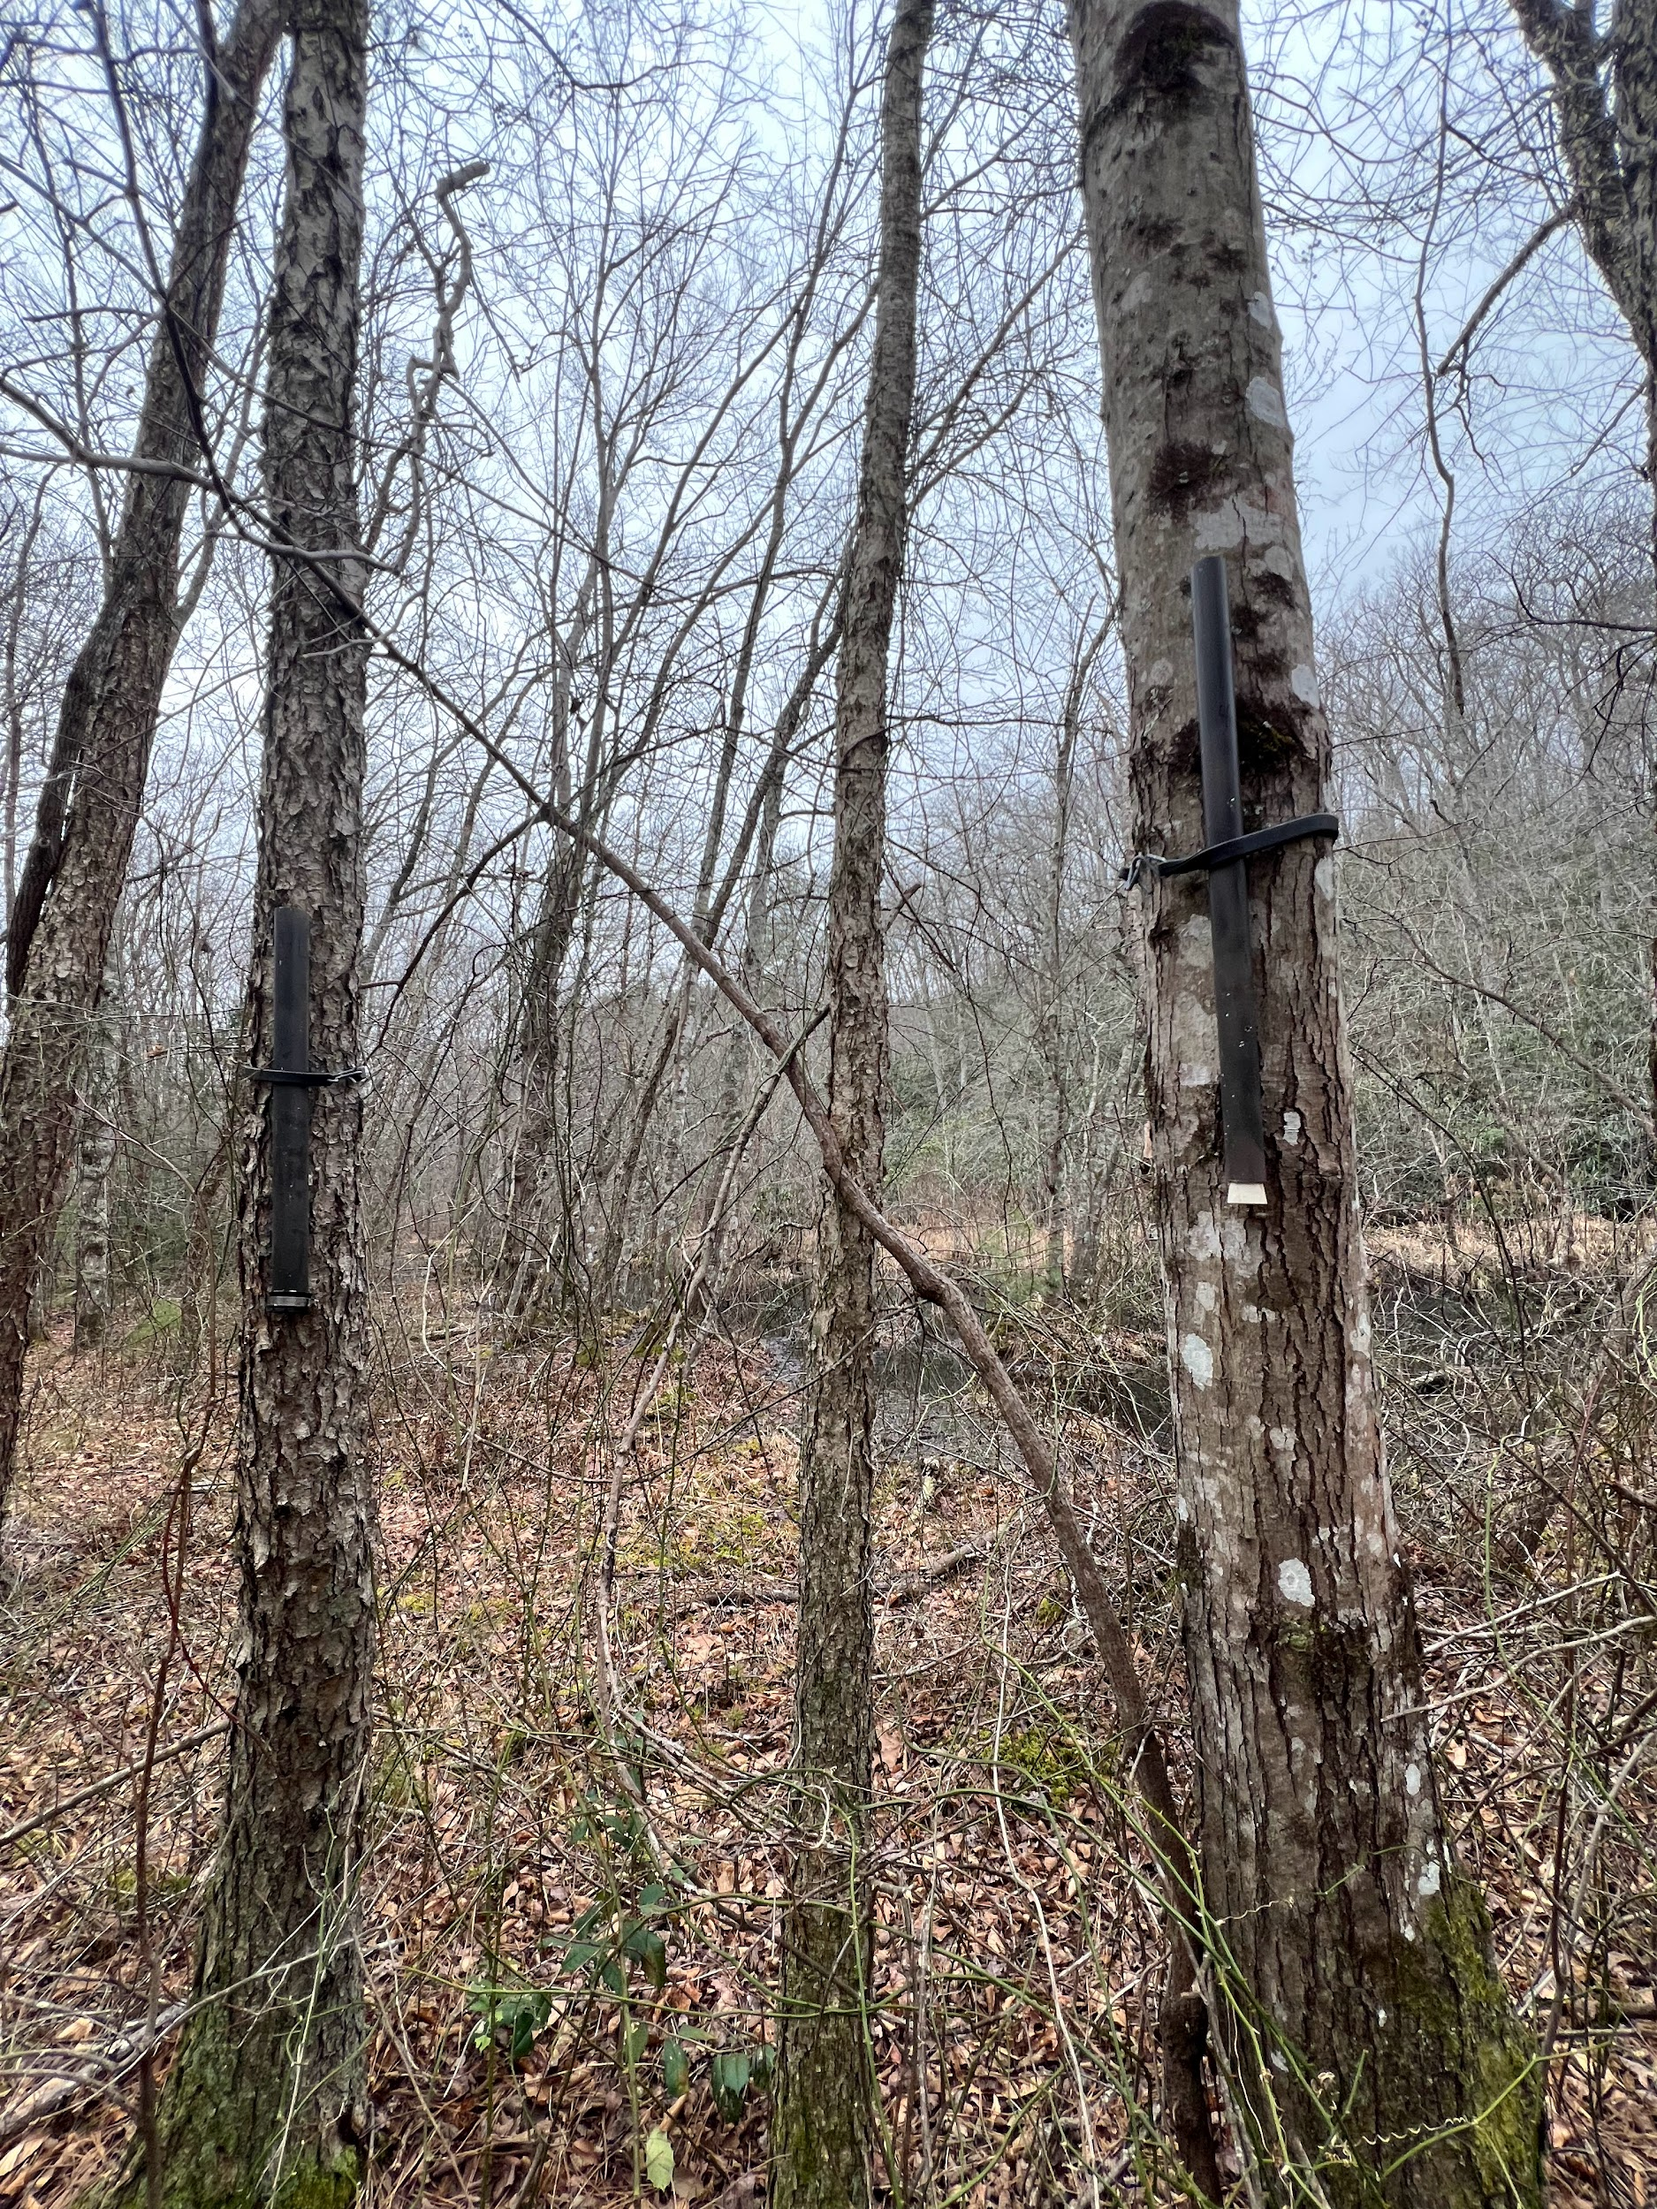

**Figure 1.** Tree tubes paired on adjacent trees, strapped 90° to the ground.

**Table 1.** Species identity, diameter at breast height (DBH), and distance from the water’s edge of trees used to mount tubes.

|  |  |  |  |
| --- | --- | --- | --- |
| **Species** | **Amount in study** | **DBH (cm)**  **mean ± SD** | **Distance from water (m) mean ± SD** |
| *Acer* | 16 | 20.60 ± 2.30 | 3.61 ± 2.55 |
| *Betula* | 17 | 22.30 ± 2.83 | 2.55 ± 2.31 |
| *Liriodendron* | 4 | 26.70 ± 2.98 | 4.50 ± 2.38 |
| *Pinus* | 1 | 18 | 1 |
| *Quercus* | 2 | 19.30 ± 4.24 | 6.85 ± 2.33 |

### 2.1.2. Amphibian traps.

For pond capture rates, we used two types of aquatic traps (**Fig. 2)**: minnow and Ortmann traps (Dreschler et al. 2010). The minnow traps are 22.86 cm x 44.45 cm mesh wire traps which contain three throats and 1.5 cm openings on each side. The Ortmann funnel traps are 11 L paint buckets with four openings, which are made by half-cut inverted plastic bottles acting as the funnels. The plastic bottles are inserted into the bucket wall and fixed with under-stable glue at the contact zone and at the wall of the bucket. The bottom of the bucket has small holes throughout for aquatic amphibian larvae to avoid injury. Two foamed tubes are placed around the upper part of the bucket wall with elastic cord in order for the Ortmann trap to float and to allow captured animals access the surface to breathe. Both these traps provide an easy access into the traps, but no exit point for the amphibians that are caught.

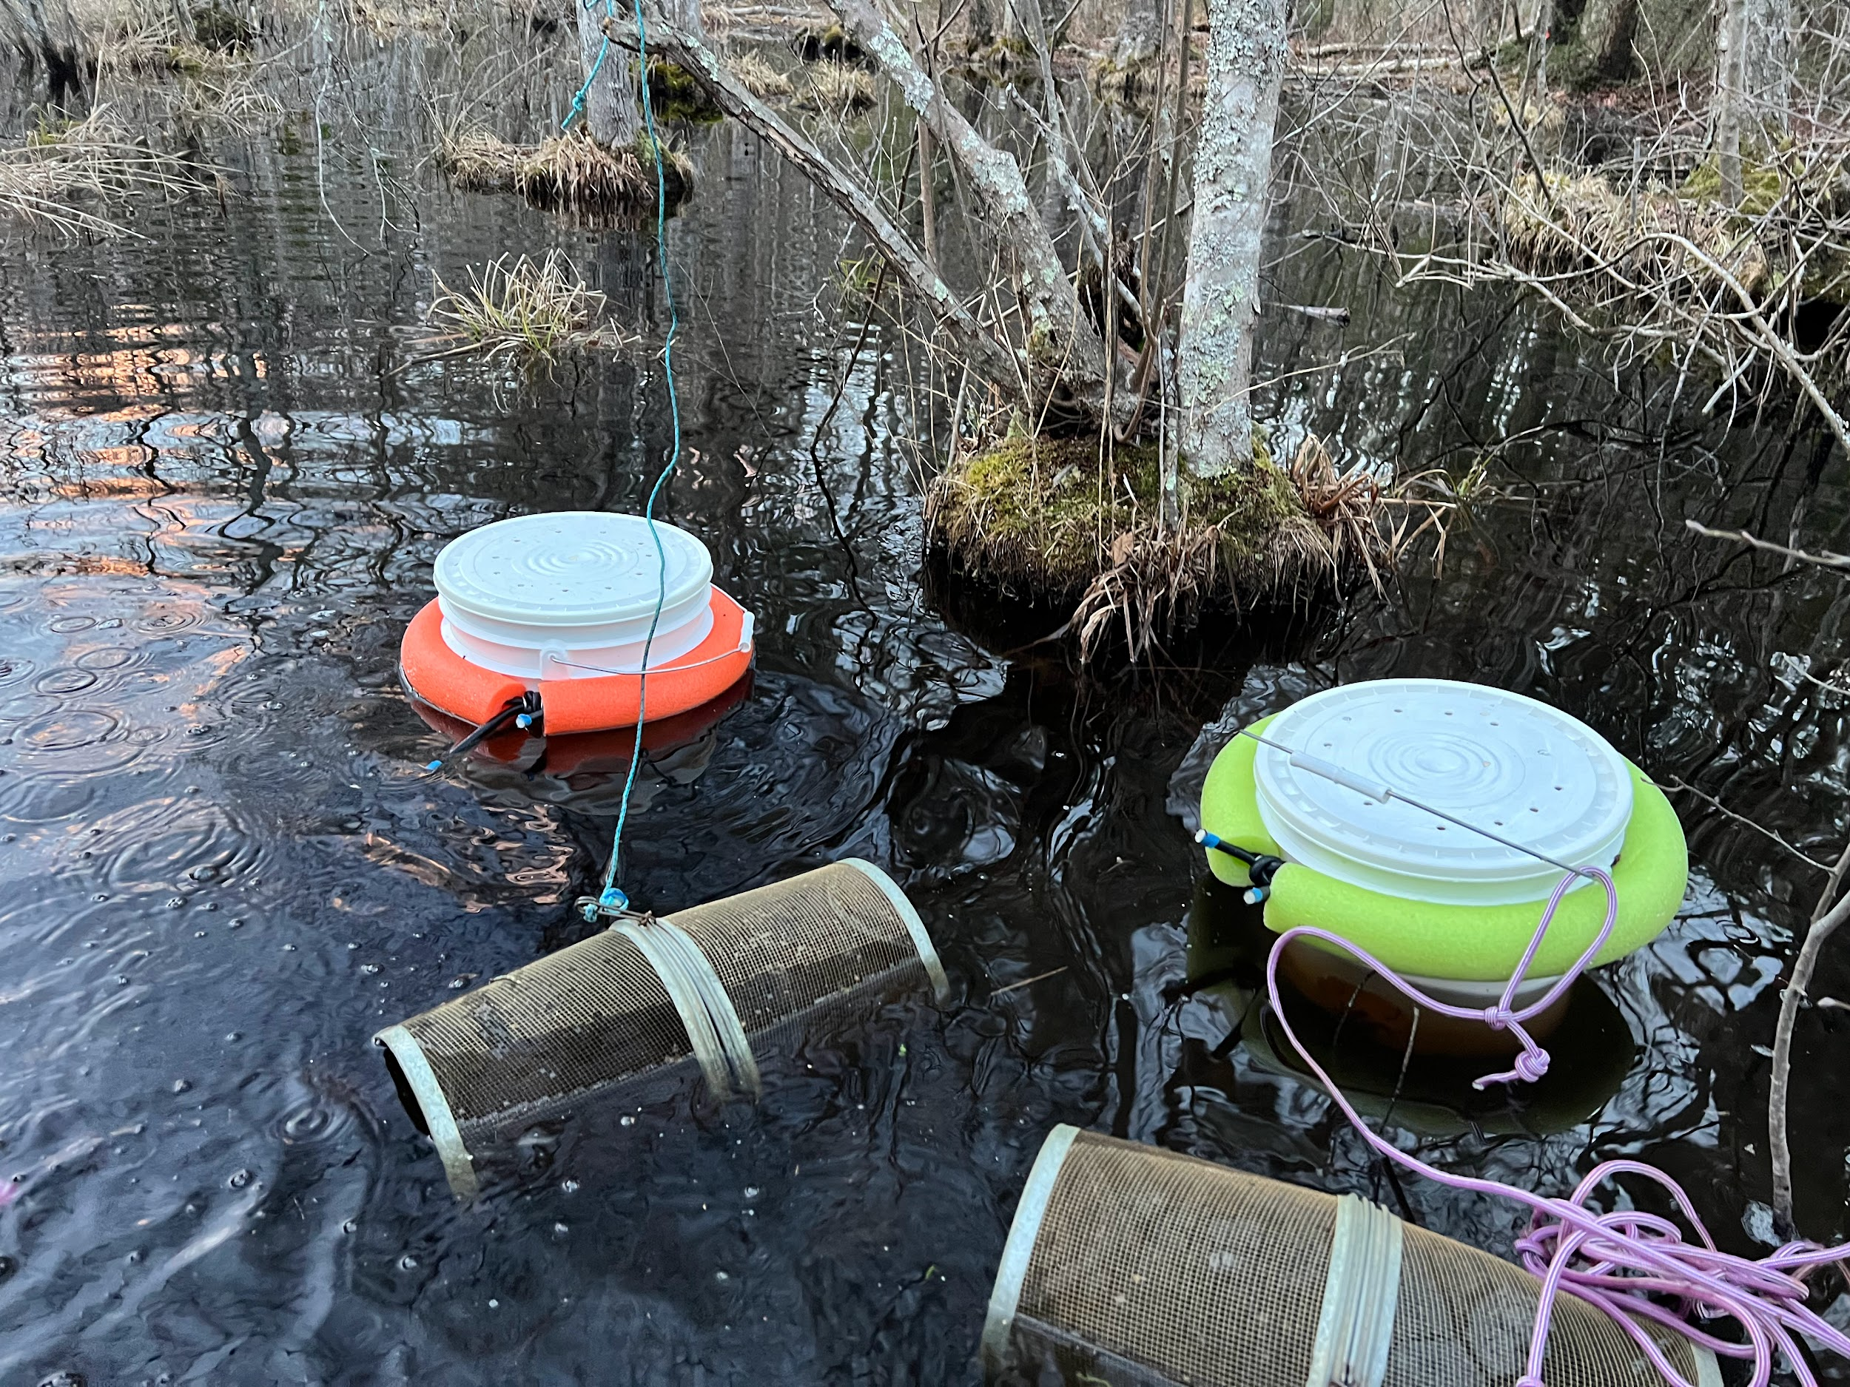

**Figure 2.** Metal minnow traps and Ortmann funnel traps used for aquatic amphibian sampling.

## 2.2. Survey methods.

### 2.2.1. Tree tubes.

Starting in July 2023, we attached these pipes in various locations throughout the wetland in a paired design, when the ponds were dry. I aimed to have the pipes be approximately 5 m from the water-line, however because of the availability of trees, this was not possible. Due to this, when the ponds were flooded again, tree refugia ended up being placed in areas in the pond, outlining the pond, and deeper in the forest away from the pond. The distances were measured when the ponds were flooded, and may or may not represent the distance at maximum flood area. These pipes were checked every other week starting in the beginning of August until mid November. During the winter season, no sampling occurred. Sampling restarted in late January, beginning weekly sampling in February. When frogs were present in the refugia, we used a damp sponge to pull the frog out of the tube in order to identify the species and record its snout-vent length (SVL).

### 2.2.2. Breeding calls.

### Previous studies (Pittman et al. 2008, Johnson et al. 2008) have found that neither species used the tree refugia during early winter months. Because of this, there was no sampling in December or January. Spring peepers breed in November until April in North Carolina (Goldberg 2023). Gray tree frogs begin their breeding season in May and go through July (Pittman et al. 2008). The site was surveyed for breeding calls of both Cope’s gray tree frogs and spring peepers and anything heard was noted. Breeding call surveys were conducted in the beginning of the breeding season for spring peepers which began at the end of February. Whenever at the site, when checking tree tubes or aquatic traps, we would also listen for any frog calls. This resulted in an hour of surveying throughout the site and taking note of anything heard.

### 2.2.3. Amphibian traps.

After the ponds flooded again, starting in early February, we placed minnow and Ortmann’s traps haphazardly throughout the main pond to survey amphibians in the wetland. This was also another individual survey method, in order to gather data on which species were occupying the water and when tadpoles of the focal species were present. There were four metal minnow traps and nine Ortmann funnel traps. The four metal traps were paired with plastic traps in order to monitor any biases present in the type of traps preferred. The traps were placed haphazardly in the wetland, were checked within 24 hours of being deployed, and species identity and abundance were recorded before releasing all captures. We also recorded the water depth at each trap location. Traps were moved to a different location after each sampling.

### 2.2.4. Weather data.

Temperature and precipitation were gathered throughout the months where the tree tubes were mounted on the site. Daily high temperature, low temperature, and precipitation were obtained from the National Weather Service (NWS 2024) from July 2023 to March 2024. The weather station is located at the Asheville Regional Airport, 8 miles from the site of study.

# Results

### 3.2.1. Tree tubes.

Although we heard the spring peepers and captured them in amphibian traps, there were no anurans found in the tree tubes.

### 3.2.2. Breeding calls.

There was anecdotal evidence of spring peeper choruses first heard in Buncombe county on February 11. They were heard at the study site on three separate occasions starting on February 27, as well as on February 28 and March 9. These choruses coincided with warmer nighttime temperatures **(Fig. 3)** and the historic beginning of spring peeper breeding season in our area. It is expected the same will happen with Cope’s gray tree frogs beginning in May, when their breeding season is expected to begin.

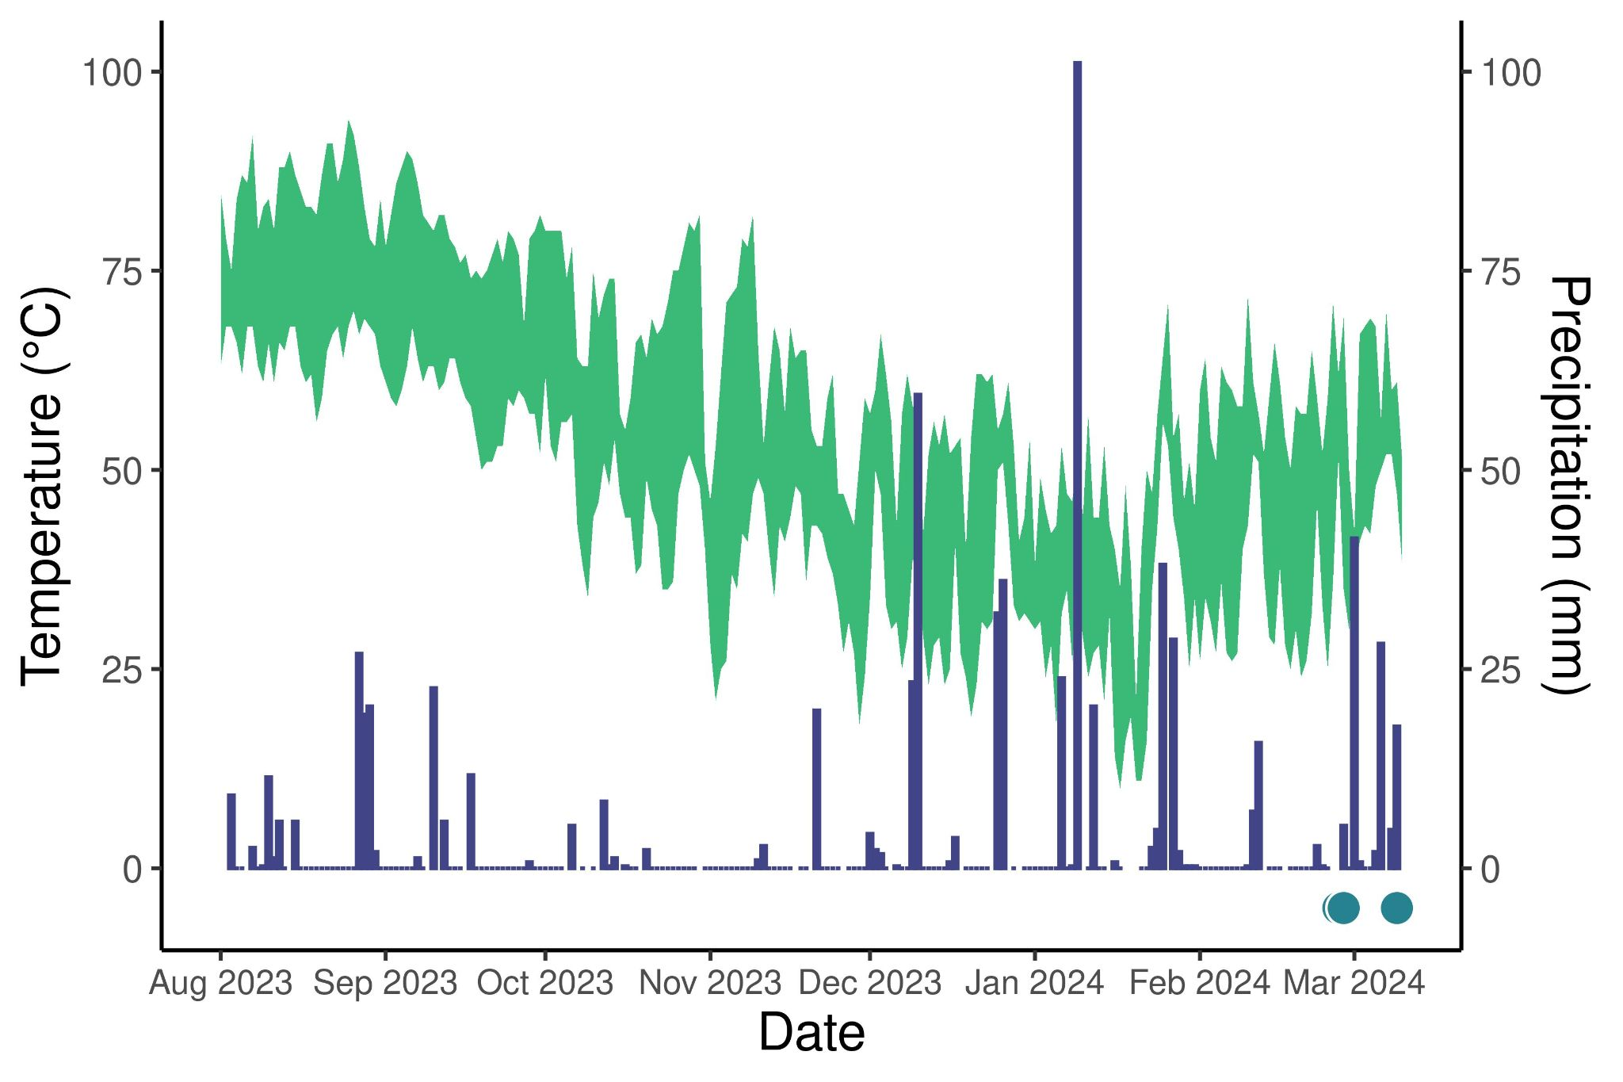­­

**Figure 3.** The high-low temperature (green line plot, left axis) and precipitation (blue bar plot, right axis) throughout surveying. Bar = spring peeper breeding season based on calling heard at other sites in Buncombe County. Dots = days we heard calls.

### 3.2.3. Amphibian traps.

We found five amphibian species and one crustacean species in the aquatic traps **(Fig. 4)**. The most abundant species found in traps were the Eastern newts (*Notophthalmus viridescens*), at 282 individuals, followed by spotted salamanders (*Ambystoma maculatum*), at 140 individuals. We also found one four-toed salamander (*Hemidactylium scutatum*) and 72 mole salamanders (*A. talpoideum).* We also found 39 *Ambystoma* larvae in the Ortmann funnel traps, which could be useful in future sampling for any larvae. Four crayfish, not identified to species, were captured. More amphibians were found in traps that were placed at intermediate depths, from ~18-25 cm, than at shallower or deeper depths **(Fig. 5)**. Out of the 216 traps that were deployed in the pond, only 12 were found empty and these ranged in depth from 11-34.5 cm.

Following three weeks of regular trap sampling (**Fig. 4**), samples were again deployed on April 9 during a rain event. Seven adult spring peepers were captured in the traps on April 10, including two pairs in amplexus.

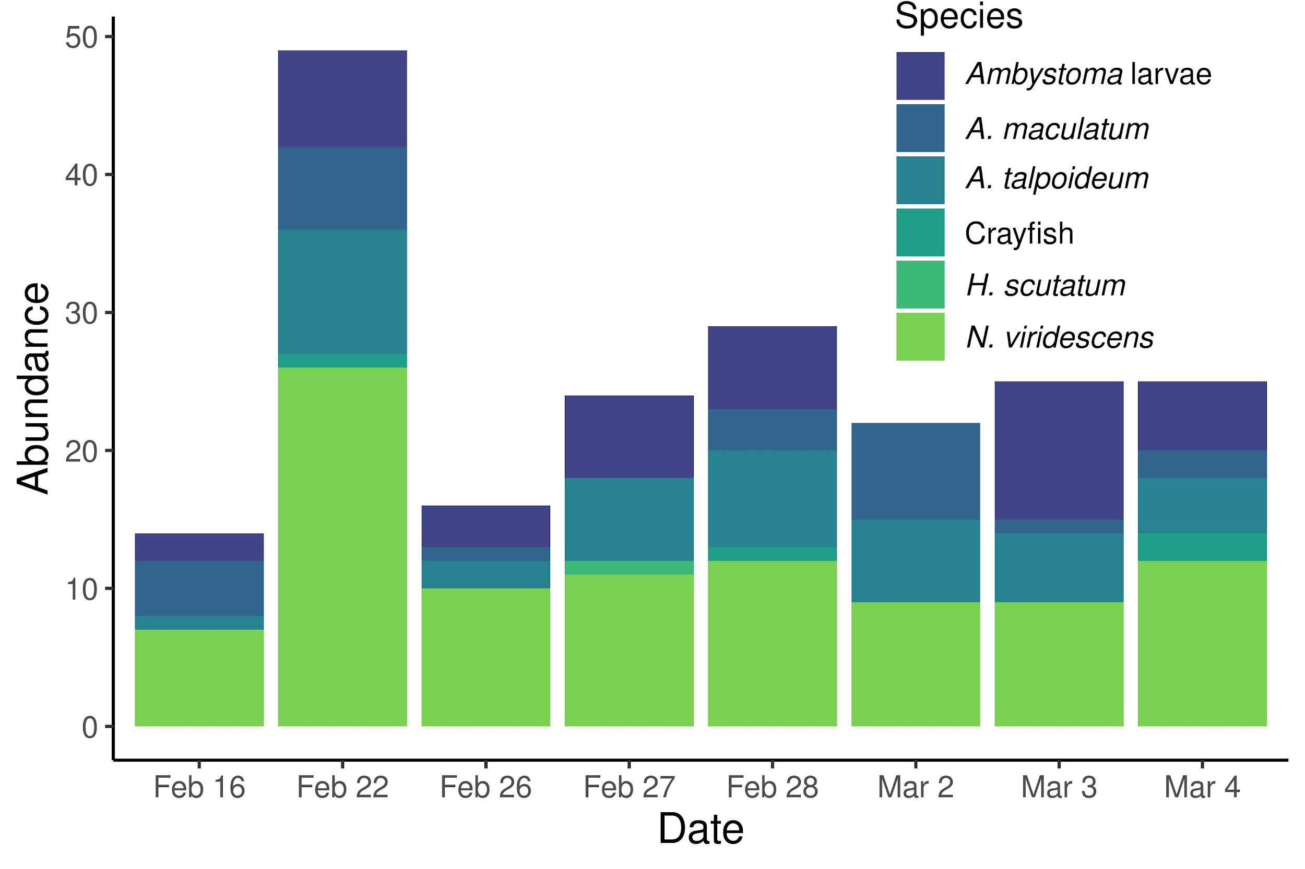

**Figure 4.** Abundance of amphibians and crayfish captured in traps.

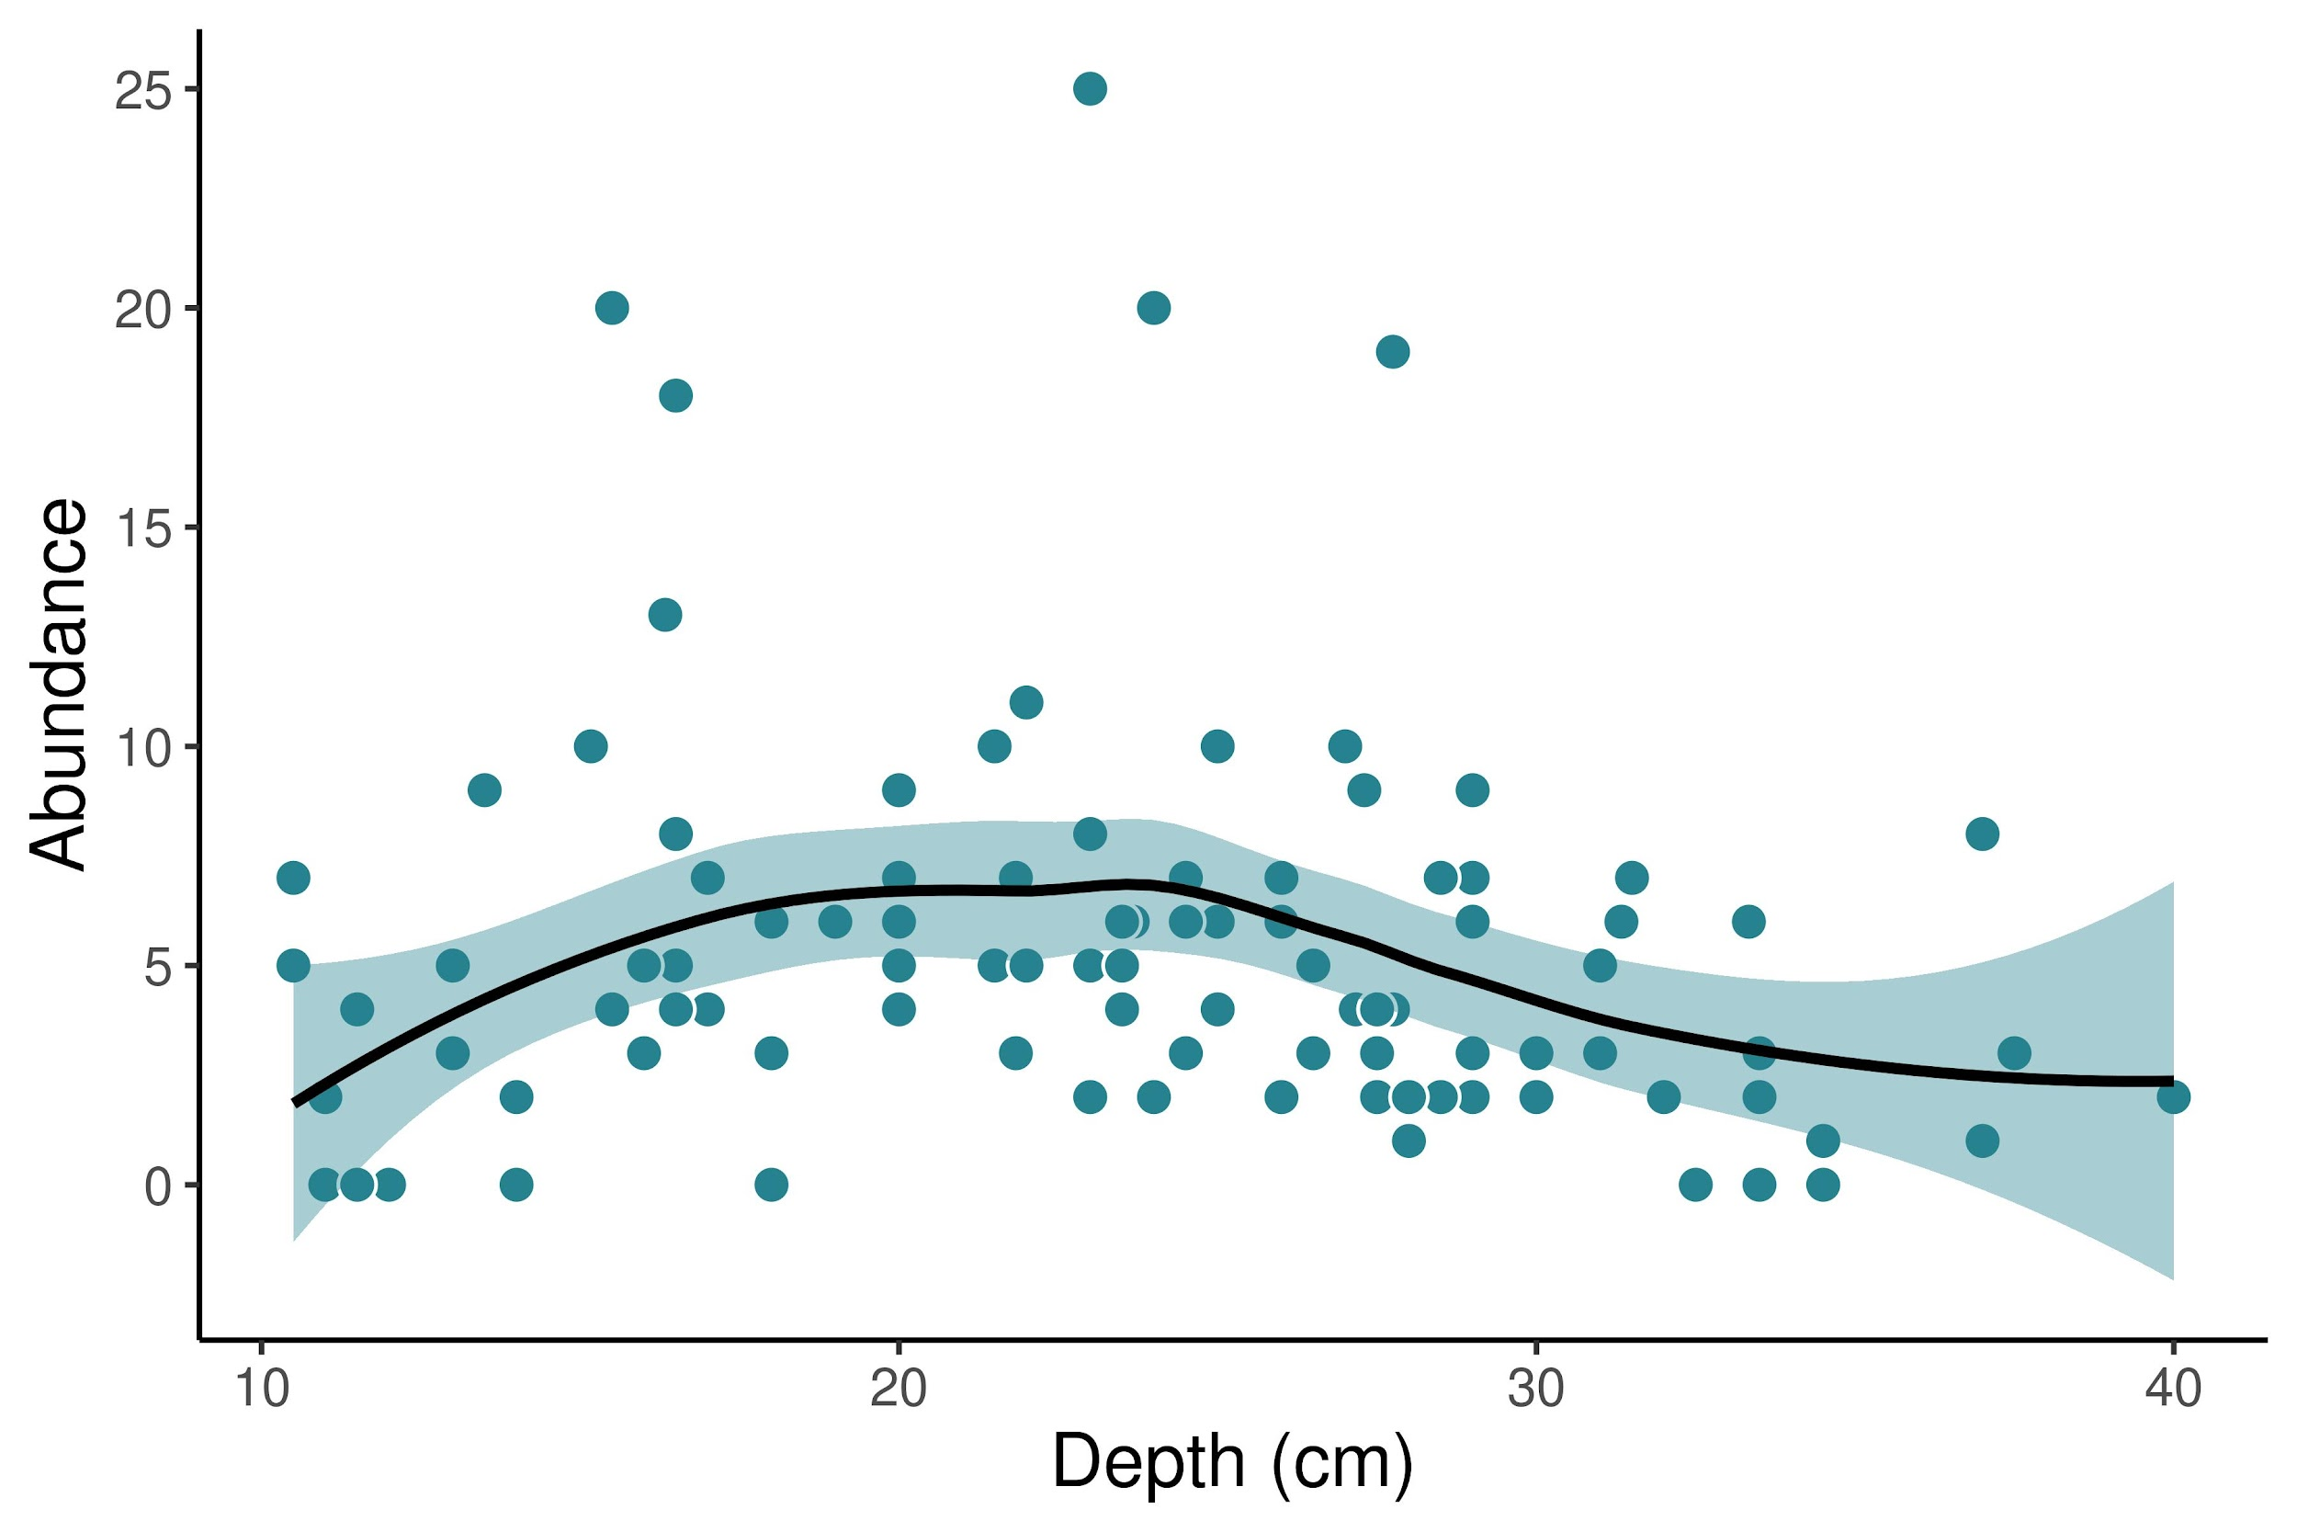

**Figure 5.** Relationship between trap depth and capture abundance for 216 traps deployed between February 16 and March 4, 2024.

# Discussion

Consistent with previous work on spring peeper phenology (Paton & Crouch, 2002), we heard choruses in February and March. Beyond pipe refugia sampling, the aquatic traps were effective in giving us results during the same period in which spring peeper chorused at the site. The absence of spring peepers in tree tubes could be explained by how they use the refugia. Previous studies found that anurans use the tree tubes during the day and return to the pond to breed at night (Zacharow et al. 2003). This implies short term residency in the wetland, and we have only sampled the beginning of the breeding season. The early breeders may not move between ponds and refugia the same way late breeders will. Further, recaptures in the same pipe were common once frogs settled into a retreat (Zacharow et al. 2003). Due to spring peepers beginning their breeding season recently, frog densities may be relatively low and natural tree refugia may not be limited. As densities increase during the season, frogs may be more likely to find the pipe refugia as retreats when natural crevices become occupied, and increase the fidelity of the tree tubes (Boughton et al. 2000).

Another explanation for the lack of frogs in the tree tubes could be that spring peeper’s breeding season is delayed. This could explain why we have only heard them on a few occasions. However their calling indicates their breeding season had begun. Further, there was no apparent delay in the breeding season of other winter-breeding amphibians: we found breeding spotted salamander, mole salamanders, and eastern newts during our February surveys and this period coincides with spotted salamander breeding in previous seasons (D’Errico et al. 2020, Hale et al. 2017, Hale et al. 2016).

Aquatic sampling was an effective method in capturing a variety of amphibian species, including spring peepers. When placing the traps haphazardly throughout the wetland, we also found that there was capture variance throughout the pond. This reinforces the effectiveness of the aquatic traps at a wide range of depths. There were 216 traps placed throughout the sampling period, positioned at depths between 10-40 cm, however there were more animals found at intermediate depths, between ~18-25 cm. These data can inform future studies of aquatic amphibians in two ways. To optimize capture rates in collection studies, the intermediate depths could be useful. For future monitoring studies, where sampling effort needs to be consistent, researchers could either choose one depth to monitor, or consistently place aquatic traps in a wide range of depths. The Ortmann funnel traps were also useful in capturing both adult and larval stages of amphibians during their breeding seasons, which could be useful in future studies of larval development in the habitat (Dreschler et al. 2010).

In summary, although not effective at detecting anuran species during our sampling period, the pipe refugia could prove to be efficient once spring peeper and gray tree frog abundance increases. Continued surveying will be useful in determining whether the pipes detect spring peepers' later pulses and the gray tree frogs’ breeding season.

# Acknowledgments

I would like to thank Gabi Parker, Rhiannon Bostian, and Ryder Mandaro for their assistance in the field. I would like to also give thanks to Dr. Graham Reynolds and Caroline Kennedy for serving on her undergraduate research committee. This research was supported by the Steve and Frosene Zeis Professorship and NSF award IOS-2219081.

# References

Boughton, R.G., Staiger, J., & Franz R. (2000). Use of PVC pipe refugia as a sampling technique for hylid treefrogs. *The American Midland Naturalist*, 144(1):168–177. https://doi.org/10.1674/0003-0031(2000)144[0168:uoppra]2.0.co;2

Buchanan, B.W. (1988). Territoriality in the squirrel treefrog, *Hyla squirella*: competition for diurnal retreat sites. M.Sc. Thesis, University of Southwestern Louisiana, Lafayette, Louisiana, USA. 132 p.

D’Errico M., Kennedy C., Hale R. (2020). Egg mass polymorphism in Ambystoma maculatum is not associated with larval performance or survival, or with cell density of the algal symbiont *Oophila amblystomatis*. *Evolutionary Ecology,* 34:981-997.

Drechsler, A., Bock, D., Ortmann, D., & Steinfartz, S. (2010). Ortmann’s funnel trap - a highly efficient tool for monitoring amphibian species*. Herpetology Notes, 3:13-21*.

Drewry, G.E. (1970). The role of amphibians in the ecology of Puerto Rican rain forest. Pp. 16–54 In *Puerto Rico Nuclear Center Rain Forest Annual Report*. San Juan, Puerto Rico.

Glorioso, B.M., & Waddle, J.H. (2014). A review of pipe and bamboo artificial refugia as sampling tools in anuran species. *Herpetological Conservation and Biology*,9(3):609−625.

Goin, C.J., & Goin, O.B. (1957). Remarks on the behavior of the Squirrel Treefrog, *Hyla squirella*. *Annals of Carnegie Museum* 35:27–36.

Annals of Carnegie Museum 35:27–36.Goldberg, S. (2023). Notes on reproduction of Spring Peepers, *Pseudacris crucifer* (Anura: Hylidae), from Oklahoma. *Bulletin of the Chicago Herpetological Society*, 58(4):58-62.

Graeter, G. & Hale, R.E. (2019). Sandy Bottom Conservation Plan. *University of North Carolina Asheville*, 129 pages.

Hale R., Kennedy C., Winkelman D., Brown C. (2017). An advantage of clear over white egg mass morphs in metabolically demanding microhabitats suggests a role of symbiotic algae in the maintenance of a polymorphism in the spotted salamander (*Ambystoma maculatum). Evolutionary Ecology Research,*18: 637-650.

Hale R., Miller N., Francis A.R., Kennedy C. (2016). Does breeding ecology alter selections on developmental and life history traits? A case study in two Ambystomatid salamanders. *Evolutionary Ecology,* 30:503-517.

Johnson, J.R. (2005). A novel arboreal pipe-trap designed to capture the Gray Treefrog (*Hyla versicolor*). *Herpetological Review,* 36:274–277.

Johnson, J.R., Mahan, R.D., & Semlitsch, R.D. (2008). Seasonal terrestrial microhabitat use by Gray Treefrogs (*Hyla versicolor*) in Missouri oak-hickory forests. *Herpetologica*, *64*(3), 259–269. https://doi.org/10.1655/07-064.1

Lee, J., Ryan, M.E., Hamlet, A.F., Palen, W., Lawler, J.J., & Halabisky, M. (2014). Projecting the hydrologic impacts of climate change on montane wetlands. *PLoS ONE,* 10(9):e0136385.

Lohoefner, R. & J. Wolfe. 1984. A new "live" trap and a comparison with a pit-fall trap. *Herpetological Review,* 15:25–26.

McGrath-Blaser, S., Neighbors, A., & Hyman, O. (2021). Novel, less invasive hylid survey device performs equally to traditional pipe shelters in a field-based comparison. *Herpetological Conservation and Biology*, *16*(2), 355–360.

Paton, P.W., & Crouch, W.B. (2002). Using the phenology of pond‐breeding amphibians to develop conservation strategies. *Conservation Biology*, *16*(1):194–204. https://doi.org/10.1046/j.1523-1739.2002.00260.x

Pittman, S.E., Jendrek, A.L., Price, S.J., & Dorcas, M.E. (2008). Habitat selection and site fidelity of Cope’s gray treefrog (Hyla Chrysoscelis) at the aquatic-terrestrial ecotone. *Journal of Herpetology*, *42*(2):378–385. https://doi.org/10.1670/07-1702.1

Ryan, M.E., Palen, W.J., Adams, M.J., & Rochefort, R.M. (2014). Amphibians in the climate vise: Loss and restoration of resilience of montane wetland ecosystems in the western us. *Frontiers in Ecology and the Environment*, *12*(4):232–240. https://doi.org/10.1890/130145

Zacharow, M., Barichivich, W.J., & Dodd, Jr., C.K. (2003). Using ground-placed PVC pipes to monitor hylid treefrogs: capture biases. *Southeastern Naturalist,* 2:575–590.