Amplifying Every Voice with Inclusive Pedagogies Using Oral Communication Studio
Elena Kallestinova
Massachusetts Institute of Technology
Marley stares at the blinking cursor on her laptop, the words “5-minute pitch” looming like a mountain. She has mastered how to do academic presentations. Yet, this pitch for interdisciplinary audiences is different. She can hide in her dorm, convincing herself that inspiration would strike at midnight and distracting herself with other urgent tasks, but this strategy rarely works.
Marley’s dilemma reflects a broader truth: oral communication is not one skill students are expected to have; it is a set of skills they must actively cultivate. From class presentations to conference talks to dissertation defenses and public pitches, speaking with clarity and confidence is woven into academic life and is essential for professional growth, helping students share ideas and connect with diverse audiences.
To coach students and build their oral communication skills, many universities establish communication centers. These centers develop communicative competence and teach a range of oral genres including presentations, discussions, debates, and interviews (LeFebvre & LeFebvre, 2014). Most importantly, these centers help students learn to explain and articulate their thinking. As Turner and Sheckels (2015) note in their book Communication Centers: A Theory-Based Guide to Training and Management, students often present “thoughtlets” instead of thoughts, and even more frequently spurt out “thinkies.” Communication centers, they argue, help students “turn thinkies into thoughtlets, and thoughtlets into thoughts” (p. xvii, emphasis in original).
While individual and group consultations remain the pedagogical core of most communication centers, emerging technologies, including video recording platforms, speech analysis software, and AI-powered feedback tools, offer new possibilities for student support. Tools such as PitchVantage, Yoodli, and VirtualSpeech allow students to rehearse presentations, receive automated feedback on delivery, and simulate audience environments.
However, the integration of such tools raises concerns. Some writing program administrators worry that access to self-guided technologies may lead to declining consultation numbers, potentially undermining the interpersonal, dialog-based nature of the center's support. Others view these tools as superficial substitutes for the deep, responsive conversations that consultants foster, conversations that help students clarify ideas, refine arguments, and build confidence through human connection. Additionally, administrators might worry that overreliance on automated feedback may reinforce delivery aspects of speaking, while neglecting rhetorical substance and audience awareness.
In this article, I argue that the framework of a self-guided oral communication studio complements instructor-led consultations and promotes inclusive teaching practices by helping learners build oral competency through iterative practice and feedback. Drawing on the usage data from 858 one-on-one consultations during the four years (2021-25), as well as the data patterns and client reflections from 71 studio sessions, the article examines how self-guided studio sessions supplement instructor-led sessions.
The analysis reveals that studio sessions differ meaningfully from traditional consultations, not only in format, but in pedagogical function and accessibility. Rather than replacing instructor-led consultations, the studio expands the center’s reach and invites a broader range of learners to engage with oral communication support.

Literature Review

Why Are Oral Communication Consultations So Useful?
According to the National Association of Communication Centers, there are at least 160 communication centers in the US (National Association of Communication Centers, n.d.). Communication centers primarily deliver instruction through consultations, which play an indispensable role as a pedagogical tool in building oral communication skills in communication centers. For example, Cronin et al. (2000) show that users of communication centers develop, as they call it, “rhetorical flexibility,” which helps them communicate competently across audiences and cultures (p. 68). They explain, “Students have the opportunity to learn how to adapt their communication to the specific situation” (Cronin et al., 2000, p. 68). This idea is also emphasized by Yook and Atkins-Sayre (2012), in their book on communication centers and one-on-one consultations, where they show how individual sessions help students refine rhetorical strategies, adapt to audience expectations, and strengthen argument structure. Their analysis positions consultations not merely as rehearsal spaces but as rhetorical laboratories where students learn to shape ideas for real-world audiences. Building on this, McDermott (2022) argues that consultations foster academic self-efficacy and improve performance, especially in professional settings such as NASA internships.
In addition to rhetorical gains, consultations play an important role in reducing public speaking anxiety and building confidence. Dwyer and Davidson (2012) found a positive correlation between the number of times users visited the center and their self-assessment in managing anxiety and feeling more confident as speakers. Jones et al. (2004), through qualitative analysis, show that targeted feedback in one-on-one sessions helps users manage nervousness and develop a stronger sense of self as presenters.
Beyond individual outcomes, consultations also foster relational growth. Ellis and Stuart (2021) show how consultants cultivate a sense of community within the center. They position consultations as interpersonal spaces that support both skill development and emotional well-being.

Do Consultations Have Any Faults?
Although the literature on consultation challenges remains limited, likely due to the predominance of their benefits, consultations are not without their difficulties. One persistent challenge involves providing discipline- and topic-specific feedback. Yook and Kim (2013) analyzed 1,100 oral communication consultations in their center and found that while users appreciated feedback on delivery and organization, they valued feedback on content even more, partly because it was harder for them to recognize content issues in their own presentations. However, the authors also noted that consultants struggled to give meaningful content feedback when they were not familiar with the client’s discipline or topic. This finding highlights a key tension: the more discipline-specific the content is, the harder it is for consultants to respond effectively. Unlike writing, where consultants can loop back to earlier sections of text, oral presentations do not offer that flexibility: you get what you get from listening in real time.
Another challenge involves over-reliance on human feedback and the limited role learners sometimes play in generating their own evaluative insights. Nicol and Kushwah (2024) explore the dynamic between instructor-driven feedback and students’ response to it, noting that “there is a tension between teachers providing comments to students about their work and students developing agency in producing that work” (p. 419). While instructor feedback is undeniably valuable, they argue that it can unintentionally diminish students’ autonomy when it becomes overly corrective or directive. Instead, they advocate for feedback models that prompt students to generate their own evaluative comments, fostering critical thinking and self-regulation. Although their study focuses on a teacher-student classroom interaction, the findings are relevant to communication center sessions, where consultants may unintentionally create a dependency on external feedback without actively cultivating learner agency.
In addition to disciplinarity and user agency, another challenge concerns the limited time to discuss a client’s work during consultations, which can narrow the scope and depth of support that consultants are able to offer. Mutsvairigwa et al. (2024) report that tutors often face time constraints that restrict their ability to address both higher-order concerns, such as rhetorical framing, argument structure, and audience awareness, and lower-order issues, including grammar, pronunciation, and delivery. These time constraints also prevent full presentation rehearsals and can leave delivery underdeveloped, especially for users who need fluency and confidence-building through repetition.
To address some of these challenges, communication instructors have begun incorporating additional tools that support learners in mastering skills, building competencies, and developing agency and self-efficacy. Among these tools are software platforms and AI-mediated applications.

What Technologies Are Used for Oral Communication Training?
Recent research has increasingly explored how AI-mediated tools can support the development of oral communication skills, particularly within English language learning programs. These tools are gaining popularity for their ability to offer targeted feedback on pronunciation, fluency, and delivery. For example, Fathi et al. (2024), conducted a controlled study with 65 participants and found substantial improvements in speaking proficiency through AI-supported activities with Andy English Chatbot. Similarly, Harahap and Dalimunthe (2024) also reported growth in speaking skills through the use of SpeechAce, an application designed specifically for oral communication development. Furthermore, Hidayatullah (2024) examined the impact of TalkPal.AI in a four-participant study and found that college students who practiced regularly with the tool showed improvement in speaking ability compared to the control group. Taken together, these studies suggest that AI-mediated platforms can effectively complement instructor-led sessions by offering personalized support across diverse learning contexts.
In addition to language learning contexts, some communication centers have also embraced technology to support student development across disciplines. Clemson’s Communication Studio, launched in 2004, is an early example of this integration (Bridwell-Bowles, Powell & Choplin, 2009). Designed as a multimodal space for oral, written, and digital communication, the studio offers collaborative workstations and tools for video editing and visual design. These resources allow users to engage with their projects, often beyond the constraints of a single consultation, and encourage autonomy through self-directed work (Clemson University, n.d.).
Eastern Kentucky University’s Noel Studio for Academic Creativity similarly foregrounds technology as a scaffold for learning. Located in the university’s main library, the Studio includes invention spaces with digital whiteboards, rehearsal rooms with recording capabilities, and breakout areas for collaborative planning. Students use large monitors to refine visual aids and research posters, while consultations focus on transferable skills such as audience awareness, revision strategy, and rhetorical framing. The Studio’s design reflects a commitment to accessibility and learner agency, offering flexible tools that support both discipline-specific feedback and sustained engagement (Eastern Kentucky University, n.d.).
One more example of a communication studio, Engineering Communication Studio at Louisiana State University (LSU), illustrates how technology can bridge disciplinary gaps. By embedding studio support directly into communication-intensive courses, LSU created opportunities for engineering students to rehearse presentations, receive targeted feedback, and revise technical content with guidance from trained consultants (Louisiana State University, n.d.). This model not only addresses time constraints by aligning studio access with course timelines, but also supports discipline-specific learning by situating feedback within the context of students’ academic work.
Together, these examples show how technology-rich environments can extend the reach of communication centers, offering learners more time, more autonomy, and more tailored support, especially in contexts where disciplinary knowledge and repeated practice are essential. However, these three cases represent only a small sample of the many technology-focused initiatives that have emerged and expanded across the United States. This shift is predicted by Martin et al. (2017), who argue that communication centers must evolve beyond their physical boundaries by integrating technologies like virtual reality (VR), augmented reality (AR), and wearable devices (smartwatches, Google glasses). These tools can enhance accessibility and relevance of communication centers for 21st-century learners, as well as develop multimodal communication skills of students.

Could We Stay AI-free in Communication Centers?
While most communication center administrators agree that technology plays an essential role in supporting student learning, some writing program leaders express concern about the implications of AI-enhanced tools. Their hesitation often stems from a fear that such technologies could undermine the interpersonal, pedagogically rich work of consultants and other communication professionals. For example, Lindberg and Domingues (2024) surveyed writing center staff and found that 41% of respondents viewed the impact of generative AI tools as somewhat or very negative. In the same study, 26% (21 participants) reported a decline in consultations, which they attributed to students turning to AI tools instead of seeking human feedback. This trend raises questions about how AI might reshape student engagement with communication centers.
This concern is echoed in Essid and Cummins (2024), who point out that staff and administrators worry about the potential devaluation or even replacement of human tutors if institutions adopt AI without careful integration. Their analysis highlights a broader anxiety: that
AI, if positioned as a substitute rather than a complement, could erode the pedagogical value of consultations. Together, these studies suggest that administrators may be hesitant to adopt AI-powered tools, fearing that such tools could reduce student engagement with human consultants and undermine the pedagogical value of interpersonal writing support.

Communication Centers Should Not Wait Anymore
Technologies continue to evolve rapidly, and their integration into learning environments is no longer optional, but rather inevitable. New software and Gen AI tools emerge daily, and their adoption among students is accelerating. According to the recent Digital Education Council’s Global AI Student Survey, 86% of students use various Gen AI tools. The data is based on 3,839 responses collected in 2024 from bachelor, masters, and doctorate students from 16 countries. Another study, conducted by Zhao et al. (2024), explored how undergraduate and graduate students who self-identified as having learning disabilities, including ADHD, dyslexia, dyspraxia, and autism spectrum conditions, were using generative AI tools. This study identified that 77% (96 participants) reported regularly using these tools to support their learning. These findings suggest that AI technologies are not only accessible but also perceived as beneficial by students who may face barriers in traditional learning environments.
As risky as it may seem, writing and communication centers must respond to this shift. Essid and Cummins (2024) argue that centers should take a proactive role in shaping Gen AI’s pedagogical function rather than wait for top-down mandates: “we contend that writing centers must take the lead in developing pedagogically fruitful methods for employing LLMs, thus jumping ahead of executive fiat from senior administration” (para 7). Their call echoes a broader concern: if centers do not lead, they risk being sidelined in decisions that directly affect their practice.
I believe that we should take the call that Martin et al. (2017) make to move beyond the comfort of familiar consultation models and embrace new modalities. Their work highlights the need for adaptive pedagogies that reflect the realities of contemporary learners. In my study, I propose a model that integrates oral communication technologies into the consultation ecosystem. Using a case study at an R1 research institution, I examine both instructor-led and self-guided studio sessions, combining quantitative and qualitative analysis. I argue that technology-enhanced studios equipped with rehearsal software, feedback platforms, and multimodal tools can supplement face-to-face consultations and expand the offerings of communication centers. Rather than replacing human support, these tools extend it, providing learners with more time, autonomy, and opportunities to build fluency and confidence.

Methodology
In order to determine how AI-mediated technologies can be integrated into oral communication support, I analyzed the center’s oral communication consultations from September 2021 through June 2025 and reviewed the appointment data in the oral communication studio collected through the WCOnline schedule from February through July 2025. I also evaluated users’ surveys for these consultations.

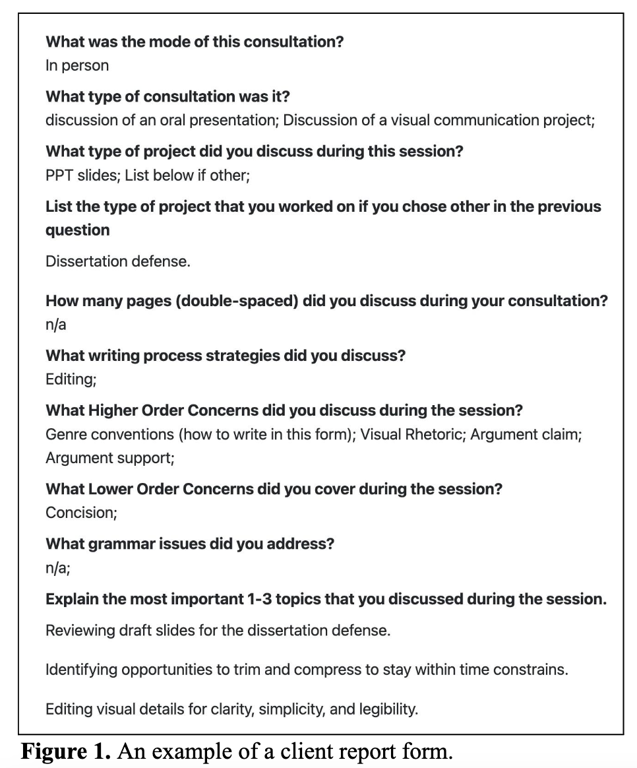
Consultation Data
The Writing and Communication Center offers face-to-face consultations either in-person or via Zoom depending on users’ preference. All consultations in the center are offered by seven professional instructors with a PhD or an Advanced Degree (EdD, MFA, or MA). Four of the instructors have worked at the center for more than twenty-five years and have significant institutional knowledge. The remaining three instructors have five years or more of consulting or coaching experience and from 10 to 20 years of teaching experience.
The center collects registration, appointment, and client report data. Registration data is submitted by users when they register for the WCOnline and includes their academic, linguistic, and demographic information. Appointment data that users submit when they schedule a consultation contains information about the goals for the upcoming consultation, the audience for their project, the deadline, and their expectations. Finally, and importantly, client report for are completed at the end of the consultation by consultants and include the project(s) the consultants worked on, the types of concerns that they addressed and the themes they covered and focused on during each session. The latter is presented as a descriptive reflection on the session. An example of a completed client report form is presented in Figure 1.
For this study, I analyzed data collected via WCOnline from September through June across four academic years: 2021–22, 2022–23, 2023–24, and 2024–25. All consultation records (n = 13,662) were anonymized and de-identified prior to analysis. To focus on oral communication projects, I sorted consultations by the project discussed during sessions and selected only those that addressed oral communication (n = 858).
This subset was analyzed to identify topics and thematic categories discussed with the instructor. Only consultants’ notes were used to determine the genres and topics addressed, as clients occasionally shifted focus between what they initially planned to discuss and what they ultimately brought to the session. To determine the frequency of topics discussed in oral communication sessions, I coded the descriptive session text for six themes and 22 topics, which are listed in Table 1.
To increase the accuracy, the descriptions were coded using a multi-label approach, where each description is matched with each of the 22 topics in a matrix. If one of the 22 topics was mentioned in the description, it was coded as “1,” and if it was not mentioned, it was coded as “0.” If a response touches on multiple topics (e.g., “needed more evidence and better eye contact”), it was coded as “Evidence and support” = 1 and “Eye contact” = 1. The rest of the topics would receive “0.” Fully coded tables were created for each academic year, and aggregate counts were generated for each topic.

Themes | Topic | Definition | Keywords
Rhetorical Situation | Audience Awareness | Speaker’s adaptation to disciplinary, interdisciplinary, or lay audiences; consideration of prior knowledge. | audience, listeners, accessible, technical, general, assume knowledge, too detailed, too vague.
Rhetorical Situation | Genre Expectations & Conventions | Alignment with norms of a specific presentation genre, including conference talk, class presentation, defense, etc. | conventions, format, style, disciplinary norms
Content Development | Opening & Conclusion | Effectiveness of introductions, previews, conclusions, and takeaways. | hook, start, opening, closing, ending, conclusion, takeaway.
Content Development | Organization & Structure | Logical sequencing of ideas, flow of sections, order of arguments | order, structure, outline, roadmap, flow of ideas
Content Development | Argument, Claim, Evidence & Support | Use of data, examples, citations, or reasoning to back up claims. | argument, claim, evidence, support, examples, proof, data, statistics
Visual Communi-cation | PPT Slides & Design | Clarity, readability, visual appeal of PowerPoint or similar slides | slides, PowerPoint, PPT, font size, text density, bullets
Visual Communi-cation | Figures/ Graphs/ Visuals | Use and explanation of charts, diagrams, images | figures, graphs, diagrams, charts, images, visuals
Language Clarity and Style | Transitions | Connections between sections or ideas; smoothness of movement. | transitions, moving from, linking, segues.
Language Clarity and Style | Grammar & Language Accuracy | Correctness of grammar, syntax, or language mechanics | grammar, sentence structure, tense, correctness
Language Clarity and Style | Word Choice and Verbal Clarity | Appropriateness and clarity of vocabulary used | wording, phrasing, clear language
Language Clarity and Style | Jargon & Technical Vocabulary | Appropriateness of technical terms; balancing precision vs. accessibility | jargon, technical vocabulary, terminology
Language Clarity and Style | Concision | Brevity and elimination of unnecessary words | concise, wordy, repetition, redundant
Delivery and Practice | Pronunciation | Correct and clear articulation of words | pronunciation, mispronounced, articulation
Delivery and Practice | Intonation/ Prosody | Use of pitch variation to emphasize meaning or avoid monotony | intonation, monotone, pitch, emphasis
Delivery and Practice | Rehearsal/ Talk practice | Degree of practice before the presentation | rehearsal, practice, preparation, did not rehearse, role-play, exercise, drill, mock presentation, conversational practice.
Delivery and Practice | Fluency | Smoothness and flow of speech during delivery, including natural pacing and minimal hesitations. | fluent, flow, smooth delivery, hesitations, pauses, “um,” “uh,” filler words, stumbling
Engagement and Self-Management | Body Language | Physical presence, gestures, posture, movement | gestures, posture, stance, body movement
Engagement and Self-Management | Eye Contact | Engagement with audience through gaze | eye contact, looking at slides, looking at audience
Engagement and Self-Management | Time Management | Staying within the allotted time; pacing | time management, length, pacing, too fast, too long
Engagement and Self-Management | Nervousness & Anxiety | Speaker’s visible nervousness or anxiety. | nervous, anxious, stress, comfort
Engagement and Self-Management | Confidence | Speaker’s confidence and authority | confident, unsure, hesitant
Engagement and Self-Management | Comprehension & Listening | The speaker’s ability to listen actively, respond appropriately to questions or feedback, and demonstrate understanding during interactive parts of the session. | listening, comprehension, response, understanding, follow-up
Table 1. Types of oral communication themes.

Oral Communication Studio Data
The Oral Communication Studio provides users with self-guided practice sessions in a dedicated space equipped with a computer, large TV screen, and a podium for presentations. These sessions are designed to simulate real-world presentation environments and support independent rehearsal. A photograph of a scholar presenting in the studio is shown in Figure 2.

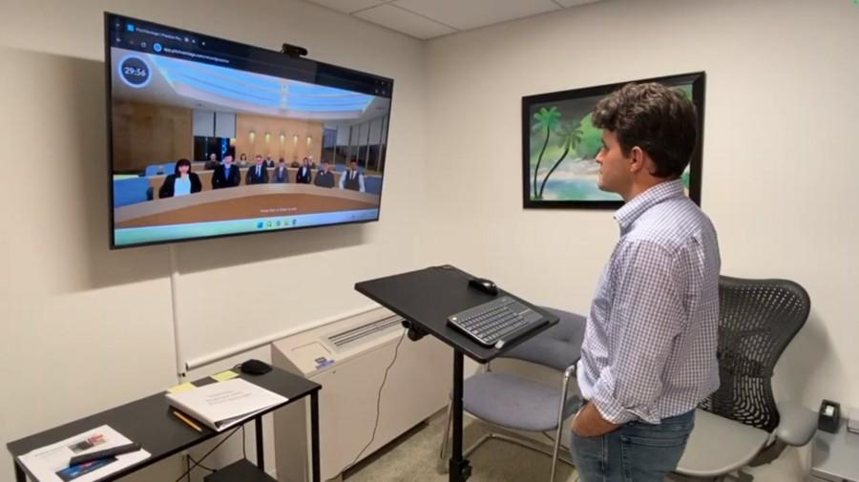
Figure 2. Oral communication studio at the writing and communication center.

Users schedule studio sessions through the same WCOnline platform as for instructor-led consultations, selecting a separate schedule from the front page. To book a session, they complete an appointment form and receive automated confirmation and reminder emails with instructions. Following each session, users are invited to complete a brief survey.
During the session, users practice using a licensed software, PitchVantage, that offers several practice formats. These formats include elevator pitches, virtual and in-person presentation rehearsals, mock interviews, and behavioral question practice. Each format varies in duration and is tailored to specific communicative goals.
The studio environment is designed to replicate the experience of presenting to a live audience. Once a practice format is selected, the TV screen displays an animated audience that responds to the speaker with body language such as nodding and smiling. After the presentation, the software generates a transcript and provides automated feedback on both content and delivery. Content feedback includes comments on the organization of users’ ideas, coherence and transitions, language use, filler words, and slide design, if applicable. The delivery feedback addresses body language, vocal delivery, and facial expressions.
Students rehearse presentations at their own pace, receive immediate feedback via PitchVantage software, and refine their delivery without the social pressure of a live audience. Animated audience simulations offer a low-stakes practice environment, and the AI-powered feedback mechanisms support learners across all disciplines. These features make the studio especially valuable for students who may be hesitant to seek in-person help or who benefit from repeated, self-directed rehearsal.
All data collected from studio appointments during the first semester of its use was anonymized and de-identified prior to analysis. In addition to appointment metadata, anonymous user surveys were included in the dataset.

Results

Instructor-Led Consultations
Instructor-led consultation data show a marked increase in oral communication sessions during the year when the Oral Communication Studio was launched. As illustrated in Table 2, the percentage of consultations focused on oral communication projects more than doubled from an average of 4.7% in prior years to 11.2% in 2024–25.

Academic Year | Total # of consultations | # of Oral Consultations | % of Oral Consultations
2021-22 | 3564 | 160 | 4.5%
2022-23 | 3514 | 156 | 4.4%
2023-24 | 3241 | 166 | 5.1%
2024-25 | 3343 | 376 | 11.2%
Total | 13,662 | 858 | 6.3%
Table 2. Sessions on oral communication projects by academic year.

Several explanations could account for this shift. One possibility is that faculty began assigning significantly more oral communication projects. However, this seems unlikely given that the majority of users are graduate students, postdoctoral scholars, and research professionals, groups whose consultation patterns are not typically driven by course assignments.
Another hypothesis is that the rise of Gen AI reduced demand for writing support, prompting users to seek help with oral communication instead. Yet this explanation is also problematic: if users were substituting oral consultations for writing support, we would expect to see a decline in overall writing support, which did not occur.
A more plausible explanation is that the Studio improved users’ ability to identify and affiliate their oral communication needs with the center’s services. The dedicated space, branding, and pedagogical framing of the Studio may have clarified the relevance of oral communication support, leading to increased scheduling and engagement.

Distribution of Oral Consultations by Academic Role
An analysis of oral communication consultations revealed distinct patterns in user roles (Figure 3). Graduate students accounted for the majority of these consultations (466 sessions or 54.3%), followed by research professionals (207 sessions or 24.1%), including faculty, lecturers, research scientists, and academic staff. Postdoctoral scholars scheduled 113 sessions (13.2%), while undergraduates scheduled only 72 sessions (8.4%).

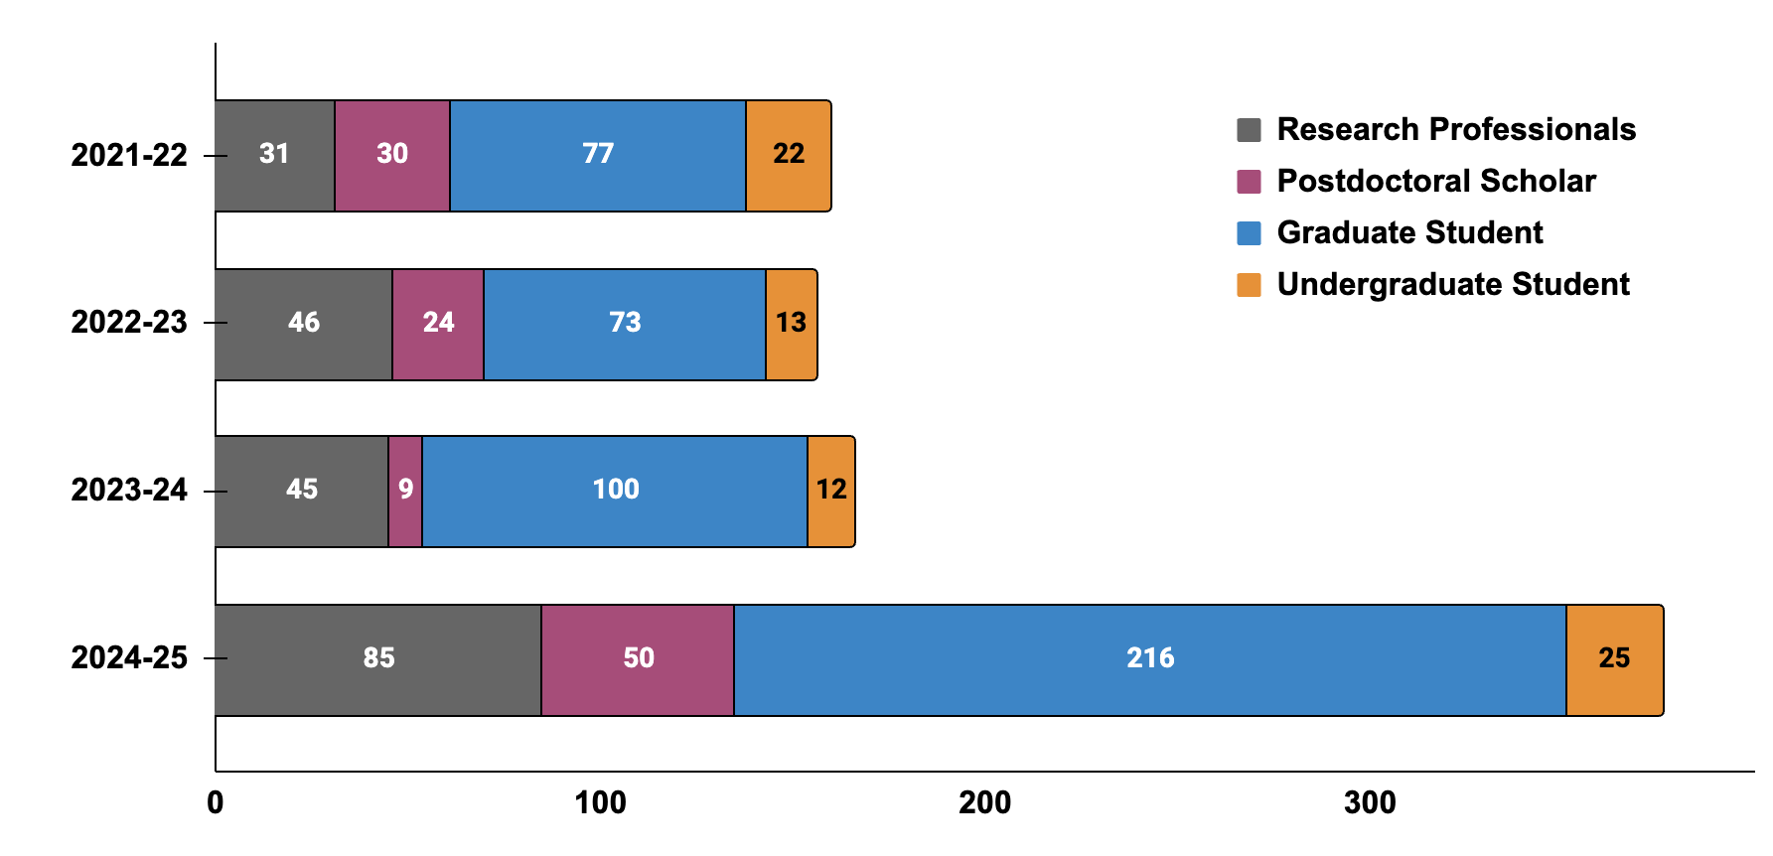
Figure 3. The number of oral communication consultations by research professionals, postdoctoral scholars, graduate students, and undergraduate students by year.

When compared to overall consultation data, the proportion of oral communication sessions scheduled by graduate students and research professionals closely mirrors their general usage rates (Table 3). However, postdoctoral scholars schedule oral communication consultations at a higher rate than their overall consultation share, while undergraduates schedule them at a significantly lower rate.

Role | Sessions on Oral Communication | All Consultations | % of Oral Consultations from All Consultations
Research Professionals | 207 | 3230 | 6.41%
Postdoctoral Scholar | 113 | 1185 | 9.54%
Graduate Student | 466 | 7102 | 6.56%
Undergraduates | 72 | 2145 | 3.36%
Table 3. Oral communication consultations vs. all consultations by users with different roles.
These patterns suggest that graduate students and research professionals engage consistently across both written and oral support, indicating a balanced use of available resources. In contrast, the discrepancies for postdocs and undergraduates may reflect deeper structural and experiential differences.
One plausible explanation is that postdoctoral scholars engage in more oral communication tasks, including conference presentations, job talks, and teaching, than undergraduates, whose coursework may emphasize written assignments. Demographic factors may also play a role: approximately 70% of postdocs at our institution are international scholars, compared to 11% of undergraduates. International postdocs may seek additional support to navigate linguistic and cultural nuances in spoken English, while native-speaking undergraduates may perceive less need for assistance.
Another explanation for this discrepancy might be rooted in confidence and maturity. Postdocs, with more professional experience, may be more comfortable seeking feedback and engaging in critical dialogue about their oral communication. Undergraduates, by contrast, may feel apprehensive about receiving critique, especially if they associate feedback with performance evaluation. Some may also overestimate their oral communication skills based on prior success in their high school, leading to underuse of available support.

Distribution of Oral Consultations by Linguistic Proficiency
Linguistic proficiency plays a significant role in shaping patterns of engagement with oral communication consultations. Non-native English speakers demonstrated the highest level of participation, accounting for 581 sessions (71%) of all oral communication sessions. The remaining consultations were divided between multilingual users who self-identify as having native-like English proficiency (147 sessions or 15.2%) and native English speakers (130 sessions or 13.8%), as shown in Figure 4.
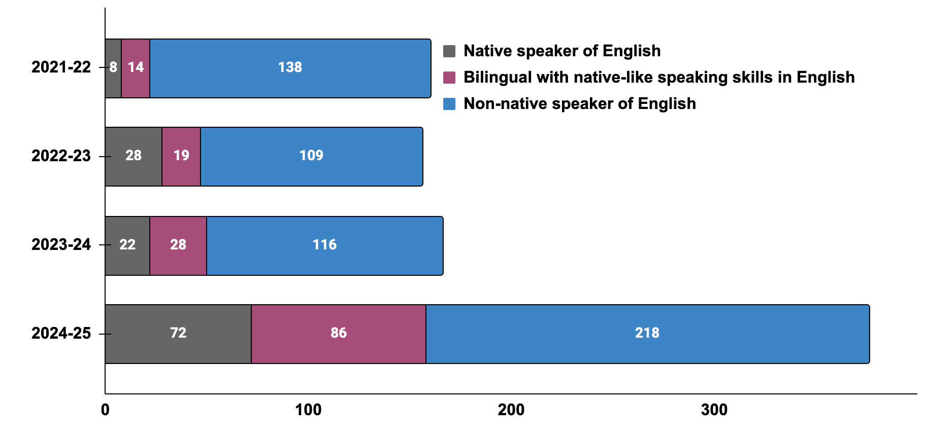

Figure 4. The number of oral communication consultations by native English speakers, multilingual speakers, and non-native English speakers by year.
When compared to overall consultation data (Table 4), the differences become more pronounced. Multilingual users engage with oral communication support at rates comparable to their general consultation usage (6.55%). However, native and non-native speakers show divergence: native English speakers are underrepresented in oral consultations (2.75% of all consultations), while non-native speakers are overrepresented (8.68%).

English Language Proficiency | Sessions on Oral Communication | All Consultations | % of Oral Consultations from All Consultations
Native speaker of English | 130 | 4721 | 2.75%
Bilingual with native-like speaking skills in English | 147 | 2245 | 6.55%
Non-native speaker of English | 581 | 6696 | 8.68%
Table 4. Oral communication consultations vs. all consultations by speakers of different linguistic proficiency groups.

This discrepancy likely reflects the distinct needs and goals of each group. Non-native English speakers may seek targeted support with pronunciation, intonation, fluency, and conversational clarity, skills that are often critical for academic and professional success but less emphasized in written communication. In contrast, native speakers may approach oral consultations with different priorities, such as refining content delivery, practicing genre conventions, managing time, or building confidence.
Additionally, the lower participation of native speakers may stem from a perceived self-sufficiency in oral communication, whereas non-native speakers may be more aware of the challenges of presenting in a second language.

Distribution of Oral Consultations by Gender
Gender distribution in oral communication consultations remained relatively consistent across four years, with female users representing the majority of oral communication consultations (481 sessions or 56.1%). Male users accounted for 353 sessions (40.6%), while users identifying as “Other” and choosing not to disclose their gender comprised a small but present portion of users (1.1% and 1.1%, respectively). These trends are summarized in Figure 5.

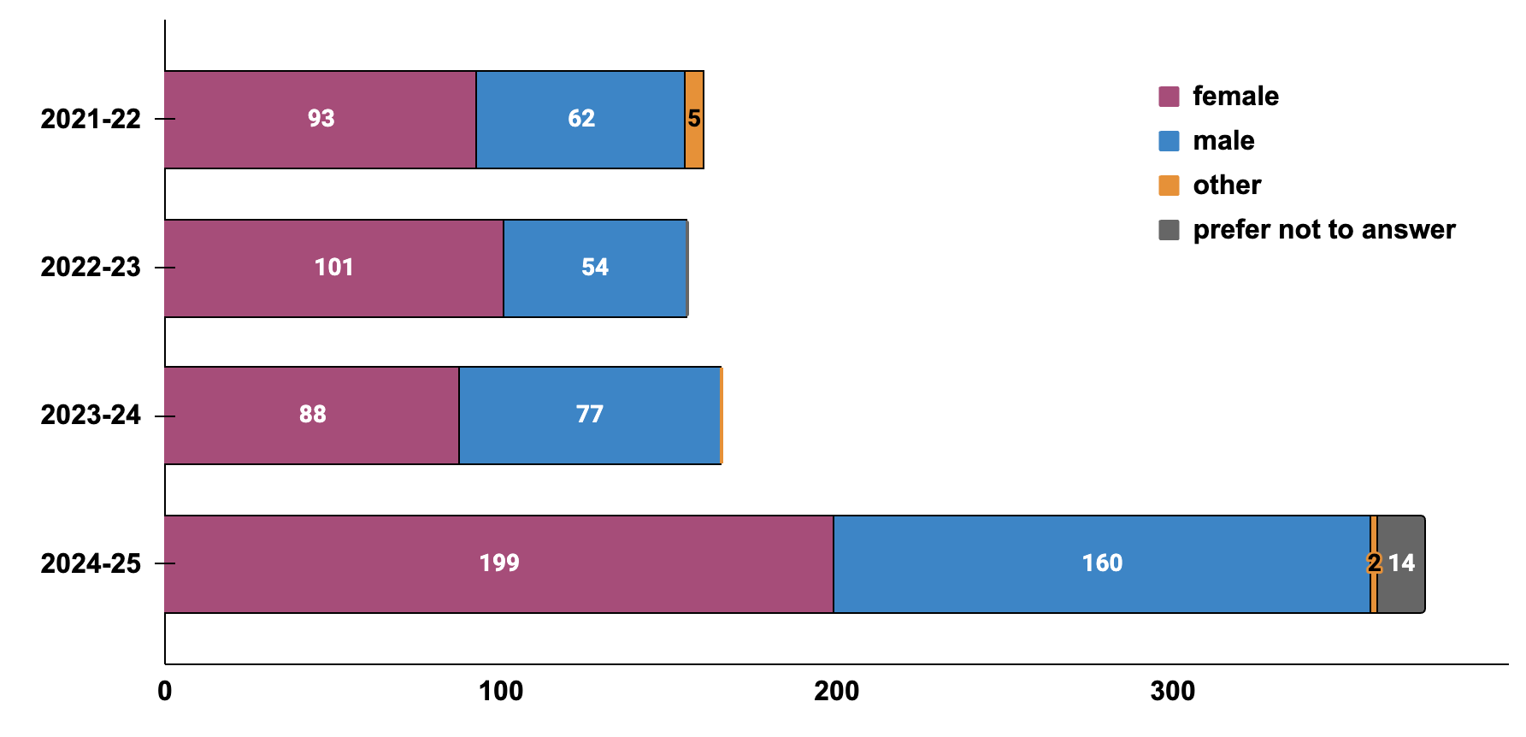Figure 5. The number of oral communication consultations across genders by year.

When compared to overall consultation data (Table 5), all four groups of users are close, with female users showing a slight underrepresentation in oral communication sessions and with male users showing a slight overrepresentation in oral communication consultations. Users identifying as “Other” or choosing not to disclose their gender are slightly less represented in oral communication sessions than in the broader consultation dataset.

Gender | Sessions on Oral Communication | All Consultations | % of Oral Consultations from All Consultations
Female | 481 | 8,342 | 5.8%
Male | 353 | 4,784 | 7.4%
Other | 8 | 199 | 4.0%
Prefer not to answer | 15 | 337 | 4.5%
Table 5. Oral communication consultations vs. all consultations across genders.

These patterns may reflect differing motivations and comfort levels across gender groups. The modest underrepresentation of female users may indicate a broader reliance on consultations for both written and oral support. Meanwhile, the slight overrepresentation of male users in oral communication consultations could suggest a targeted use of these sessions for performance refinement, confidence-building, or genre-specific practice.
The relatively low participation of users identifying as “Other” or opting not to disclose gender may point to broader issues of visibility, comfort, or perceived inclusivity in academic support spaces. These trends highlight the importance of fostering environments that are not only pedagogically responsive but also attuned to the diverse identities and needs of all users.

Distribution of Oral Consultations by Learning Disability
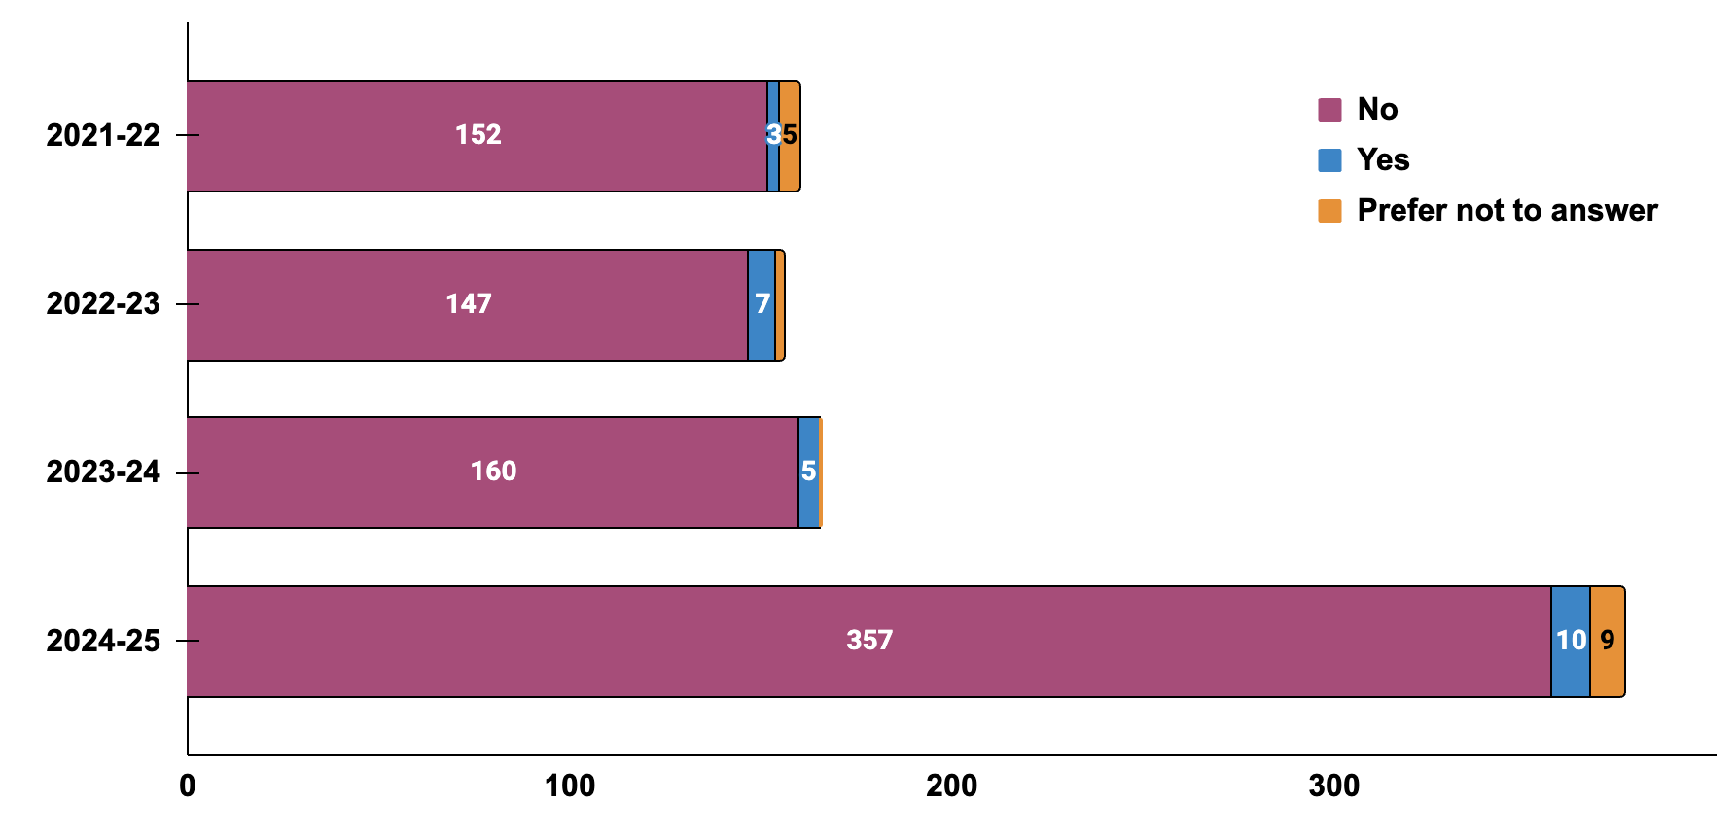
Engagement with oral communication consultations shows nuanced variation when examined through the lens of neurodiversity status. Over the four-year period, students who self-identified as having learning disabilities, including dyslexia, dysgraphia, dyscalculia, ADHD, or ADD, comprised an average of 2.9% of oral communication consultations. The majority of users (95.1%) did not report a learning disability, while 2.0% preferred not to disclose their status. These trends are summarized in Figure 6.
Figure 6. The number of oral communication consultations across different neurodiverse groups by year.

When compared to overall consultation data (Table 6), students who reported a learning disability use oral communication sessions slightly less (4.34%) than those who did not report any disability (6.69%). Interestingly, students who chose not to disclose their status are underrepresented in oral communication sessions (1.9%) compared to all consultations.
Learning Disabilities | Sessions on Oral Communication | All Consultations | % of Oral Consultations from All Consultations
No | 816 | 12,193 | 6.69%
Yes | 25 | 576 | 4.34%
Prefer not to answer | 17 | 893 | 1.90%
Table 6. Oral communication consultations vs. all consultations across neurodiverse students.

This discrepancy may reflect the specific challenges and preferences of neurodiverse learners. Students with learning disabilities often prioritize consultations that address urgent academic concerns, such as managing timelines, refining written discourse, and navigating revision strategies. In contrast, oral communication may not be perceived as an immediate or problematic area, and thus may be deprioritized in favor of written support. For many, the cognitive load and real-time demands of oral sessions may feel less pressing or more difficult to engage with productively.
A similar pattern may apply to students who choose not to disclose their learning status. These users might also gravitate toward written consultations, either due to personal preference, perceived relevance, or a desire to avoid the vulnerability that oral performance can entail. In both cases, the lower participation in oral communication sessions may reflect not a lack of need, but a difference in how that need is recognized, prioritized, and acted upon.

Projects Addressed During Oral Consultations
The analysis of 858 client report forms across 4 years completed by consultants reveals certain patterns in genres and projects discussed and topics addressed during oral consultations. The distribution of project types discussed during oral consultations reveals role-based preferences and priorities, as shown in Table 7.

What type of project did you discuss during this session? | Research Professionals | Post-doctoral Scholars | Graduate Students | Under-graduate Students | Overall
Developing ideas for oral presentations | 1.0% | 0.0% | 1.1% | 10.4% | 1.6%
Conference Presentations | 30.4% | 26.5% | 15.4% | 4.5% | 19.6%
Oral Presentations | 27.5% | 31.9% | 25.1% | 16.4% | 25.9%
Presentation for a class | 16.4% | 13.3% | 21.5% | 37.3% | 20.4%
Pronunciation and conversation practice | 24.6% | 28.3% | 36.9% | 31.3% | 32.4%
Table 7. The distribution of projects and genres across four types of consultation users.

Research professionals, including faculty, lecturers, instructors, and research scientists, as well as postdoctoral scholars most frequently discussed conference presentations and oral presentations (58% of consultations), reflecting their professional activities and engagement in public speaking contexts. For these groups, oral consultations appear to support high-stakes, externally facing communication.
Graduate students showed a more balanced distribution, with more engagement in oral presentations (25.1%) and pronunciation/conversation practice (36.9%). This suggests a dual focus on performance and fluency, likely tied to both academic and professional development.
Undergraduate students were most frequent to discuss class presentations (37.3%) and developing ideas for oral presentations (10.4%), indicating that their consultations are often course-driven and exploratory. Their relatively high engagement in pronunciation and conversation practice (31.3%) also suggests a focus on developing speaking skills.

Single and Multi-Project Consultations
Although each consultation is limited to 50 minutes, nearly one-third of sessions involved discussion of multiple projects, as shown in Table 8.

Project Types Discussed During One Session | % of Sessions | # of Sessions
Discussions of one oral communication project | 70.5% | 605
Discussion of 2+ oral communication projects | 21.1% | 181
Discussion of one oral and one written project | 8.4% | 72
Table 8. Project types discussed during each session.

The data indicate that most consultations (70.5%) focused on a single oral communication topic, such as a conference presentation, idea development for a talk, or pronunciation practice. However, a substantial portion of sessions (29.5%) addressed multiple topics, revealing a flexible and user-driven approach to consultation time.
Most multi-project sessions (21.1%) remained within the domain of oral communication. For example, a user might split time between refining a conference presentation and practicing pronunciation or combine activities such as brainstorming for a class presentation, reviewing genre expectations, and rehearsing delivery.
Interestingly, 8.4% of sessions bridged oral and written communication. These hybrid consultations often involved pairing a written document, for example, a research statement or thesis, with an oral presentation tied to the same or a different project.
Given that consultation projects are user-driven, this pattern likely reflects strategic time management. Users may aim to maximize the value of each session by addressing multiple needs, especially when deadlines converge or when projects are interrelated. It also points to the adaptability of consultants, who respond to shifting priorities and provide support across genres and formats.

Themes and Topics Addressed During Oral Consultations
To better understand the pedagogical aspects of oral consultations, 22 coded topics were grouped into six themes: Rhetorical Situation, Content Development, Visual Communication, Language Clarity and Style, Delivery and Practice, and Engagement and Self-Management. Table 9 summarizes the frequency with which each topic appeared across four academic years.

Theme | Consultation Topic | 2021-22 | 2022-23 | 2023-24 | 2024-25 | Average
Rhetorical Situation | Audience Awareness | 23% | 27% | 26% | 24% | 25%
Rhetorical Situation | Genre Expectations & Conventions | 24% | 21% | 25% | 24% | 24%
Content Development | Opening & Conclusion | 13% | 12% | 7% | 9% | 10%
Content Development | Organization & Structure | 16% | 19% | 23% | 20% | 20%
Content Development | Argument, Evidence & Support | 19% | 25% | 19% | 23% | 22%
Visual Communication | PPT Slides & Design | 29% | 26% | 27% | 26% | 27%
Visual Communication | Figures/ Graphs/Visuals | 10% | 8% | 8% | 10% | 9%
Language Clarity & Style | Transitions | 7% | 8% | 7% | 11% | 8%
Language Clarity & Style | Grammar & Language Accuracy | 13% | 13% | 13% | 13% | 13%
Language Clarity & Style | Word Choice & Clarity | 15% | 17% | 17% | 16% | 16%
Language Clarity & Style | Jargon/ Technical Vocabulary | 4% | 6% | 5% | 6% | 5%
Language Clarity & Style | Concision | 7% | 9% | 11% | 12% | 10%
Delivery & Practice | Rehearsal | 24% | 22% | 22% | 26% | 24%
Delivery & Practice | Fluency | 21% | 22% | 24% | 19% | 22%
Delivery & Practice | Pronunciation | 26% | 24% | 30% | 24% | 26%
Delivery & Practice | Intonation | 10% | 15% | 16% | 14% | 14%
Engagement & Self-management | Eye Contact | 1% | 1% | 1% | 2% | 1%
Engagement & Self-management | Body Language | 3% | 1% | 3% | 5% | 3%
Engagement & Self-management | Time Management | 9% | 6% | 2% | 10% | 7%
Engagement & Self-management | Nervousness/ Anxiety | 5% | 5% | 4% | 5% | 5%
Engagement & Self-management | Confidence | 2% | 4% | 4% | 5% | 4%
Engagement & Self-management | Comprehension and Listening | 3% | 3% | 5% | 3% | 4%
Table 9. The distribution of consultation topics across four academic years (2021-2025).

The data reveal several consistent patterns across years. While some of the themes and topics receive more attention during the sessions, others receive less.
The two rhetorical situation topics, audience awareness and genre expectations, were discussed in nearly one-quarter of consultations each year, revealing the importance to align presentations with audience expectations, as well as disciplinary and genre conventions.
Examples of these topics are listed in Table 10.

Examples for Rhetorical Situation | Topics | Consultee
“Adding supporting details to the elevator pitch so that technical concepts become accessible to a non-technical audience.” | Audience awareness and Genre Conventions | a research scientist, Electrical Engineering and Computer Science. non-native speaker.
“Identifying the primary and secondary audiences as well as the speaker's purpose. Using audience, genre, and purpose to guide and delimit communication choices. Investing in the invention and planning stages to save time in the subsequent stages.” | Audience awareness and Genre Conventions | A Master’s student, in Economics, 1st year, School of Humanities and Social Sciences, multilingual speaker.
Table 10. Consultation Examples of Rhetorical Situations.

In addition to the rhetorical situation, the three themes that receive significant attention during consultations are content development, visual communication, and delivery & practice.
In the content development theme, the more frequent discussions centered around the argument, evidence and support, as well as organization and structure. The framing with introductions and conclusions were discussed only in 10% of the sessions. Several examples with these topics are listed in Table 11.

Examples for Content Development | Topics | Consultee
“Restructuring a presentation from a list of projects to a vision exemplified by selected projects. Backing abstract claims with concrete examples.” | Organization & Structure; Argument, Evidence & Support | Visiting Scholar, School of Architecture and Planning, Media Lab, female,  non-native speaker of English, native speaker of Chinese.
“Clarifying the problem and recommendation at the presentation's start. Linking the latter parts with the framing. Reducing the supporting details to only what's necessary.” | Opening & Conclusion; Argument, Evidence & Support | Master’s student, School of Engineering, Mechanical Engineering, male,  non-native speaker of English, native speaker of Chinese.
Table 11. Consultation examples of content development.

Slide design consistently ranked among the most frequently addressed topics (26–29%), indicating that users view visual clarity as integral to effective oral delivery. Figures and graphs appeared less often, in 8-10% of sessions. Examples with these topics are listed in Table 12.

Examples for Visual Communication | Topics | Consultee
“Creating appealing figures for slides to replace bulleted lists. Anticipating audience questions and doubts and revising accordingly.” | slide design; figures & graphs | A visiting scholar, School of Architecture and Planning, Media Lab, female,  non-native speaker of English, native speaker of Chinese.
“Identifying opportunities to reduce the visual information on particular slides. Animating highlights to emphasize a slide's main points.” | slide design | Master’s student, School of Architecture and Planning, Architecture, female,  non-native speaker of English, native speaker of Chinese.
“Locating information in the poster where viewers' eyes tend to track and land.  Strengthening transitions among sections and using verbal pointing to better integrate the oral and visual texts.  Revising from the end to strengthen and clarify the information hierarchy.” | figures & graphs | Master’s student, School of Engineering, Aeronautics and Astronautics, female, native speaker of English.
Table 12. Consultation examples of visual communication.

Another theme that was frequently addressed in consultations is Delivery and Practice. In this theme, Rehearsal and Fluency and Intonation were consistently high across all years, especially among non-native speakers of English, who used consultations to practice pronunciation and conversation for developing fluency. Examples with these topics are listed in Table 13.

Examples for Delivery and Practice | Topics | Consultee
“Applying intonation and pronunciation strategies previously practiced to a script prepared for an interview.” | Pronunciation Intonation Rehearsal | Master’s student, female, School of Management, non-native speaker of  English, speaker of Spanish.
“Practicing /w/, /v/, /dd/, /tt/, and vowel sounds through minimal pairs. Fluency practice. Expanding the repertoire of syntactical structures used in conversation.” | Pronunciation Fluency | Undergraduate student, School of Science, Chemistry major, female, non-native speaker of English, native speaker of Turkish.
Table 13. Consultation examples of delivery and practice.

The two themes that received less attention in consultations were Language, Clarity, and Style and Engagement and Self-management; these categories were discussed on average in 10% of consultations. The most frequent of them were Word Choice and Grammar/ Language Accuracy, which, based on the consultation descriptions, were addressed in 15-17% and 13% of consultations, respectively. It was indeed surprising to see that they were not discussed more frequently, given that 71% of all oral consultations were with non-native speakers of English. Consultation discussions centered less frequently around the category of Transitions, Jargon/Technical Vocabulary, and Concision. Examples with these topics are listed in Table 14.

Examples for the Language, Clarity & Style | Theme | Consultee
“Finding areas in the motivation to compress to meet a time limit.  Strengthening transitions among slides and sections to reinforce logic. Rehearsing to build confidence.” | Transitions; Concision | 4th year PhD student, male, Sloan School of Management, Operations Research Center, non-native speaker of English, native speaker of Greek.
“Ran through the presentation together. Focused on fixing grammar and capitalization, making a few explanations of terms a bit clearer, and connecting some main themes.” | Grammar/ Language Accuracy; Jargon/Technical Vocabulary | Lecturer, female, School of Humanities Arts and Social Sciences, Course 21G: Global Studies and Languages, non-native speaker of English, native speaker of Japanese.
“Clarity of phrasing. Word choice. Explaining abstract concepts more clearly and concretely. It was the "script" for a slide presentation.” | Word Choice; Concision | Faculty, female, School of Humanities Arts and Social Sciences, Anthropology, non-native speaker of English, native speaker of Mongolian.
Table 14. Consultation examples for language, clarity & style.

The theme that was the least frequent of all is Engagement and Self-management, averaging in only 4% of sessions. Topics in this theme, such as confidence, anxiety, and time management, were less frequent but still present. Their low representation may reflect users’ hesitancy to recognize and share emotional or cognitive challenges. Alternatively, users may be aware of these problems, but unwilling to address these areas. Interestingly, body language and eye contact were addressed in only 1-5% of sessions, pointing to potential gaps in non-verbal delivery support. Table 15 exemplifies each of the topics in this theme.

Examples for the Content Theme | Theme | Consultee
“Rehearsing his Research Slam talk. Managing nerves and staying present. Practicing eye contact and making gestures expansive.” | Eye Contact; Body Language; Nervousness & Anxiety | Postdoctoral scholar, male, Environmental Solutions Initiative, native speaker of English.
“Building skills and confidence in presenting herself in English.” | Confidence | Master’s student, female, School of Engineering, Supply Chain Management, non-native speaker of English, native speaker of Spanish.
“Developing their understanding of prosody in English and applying it to improve comprehensibility and engagement. Listening to a range of authentic materials to developing listening comprehension skills.” | Comprehension & Listening | Master’s student, female, Sloan School of Management, Management, non-native speaker of English, native speaker of Spanish.
Table 15. Consultation examples for engagement and self-management.

Overview of Theme and Topic Frequency in Instructor-led Sessions
The analysis of the data above shows the four categories of Rhetorical Situation, Content Development, Visual Communication, and Delivery and Practice that were frequently repeated themes during oral communication consultations, with two themes, Language Clarity and Style and Engagement and Self-Management receiving less attention.
One of the reasons explaining this pattern might be that instructors preparing clients for conference talks, guest lectures, or thesis defenses often prioritize higher order concerns before they address lower order concerns. As a result, they address rhetorical clarity, content and slide design, which are high-stakes and high-visibility topics, over language clarity and style, which may be assumed to be “good enough” and of less priority.
Another reason might be related to addressing time-sensitive and actionable goals when clients bring their presentations and talks for discussion. Indeed, rhetorical awareness, argument, organization, slides and pronunciation of key terms and certain words can be fixable within a reasonable timeframe. At the same time, engagement and self-management topics, such as managing anxiety, building confidence, or sustaining motivation, require time to fix through a series of presentations, and might be de-prioritized as less urgent.
Furthermore, in STEM and research-heavy contexts, there is often a strong emphasis on data visualization, assertion-evidence slide design, and clarity of research contribution, which align more with the high-frequency topics discussed during the sessions.
In addition to the patterns of themes that are more or less frequent, some of the topics within high-frequency themes surface more or less during consultations. This is particularly visible in the themes of Content Development, Visual Communication, and Delivery/Practice, where the topics of Introduction/Conclusions, Figures/Graphs/Visuals, and Intonation, respectively, receive substantially less attention during sessions.
These lower frequency topics point at how consultation priorities, genre expectations, and content shape what gets discussed in oral consultations. In addressing presentations, clients might want to focus on the so-called “meat” of the presentation, including methods, findings, and implications, and less on the introduction and conclusion, which are usually crafted after the talk is shaped. As a result, introductions and conclusions are left for later or prioritized as secondary.
As for figures, the lower priority might be related to the discipline-specific nature of the visuals, which might not be so clear for consultation instructors. Also figures may be treated as “given” by instructors, rather than rhetorical tools needing refinement.
Moreover, intonation is often embedded in broader fluency or pronunciation work. Unless a speaker has a specific visible prosodic concern (e.g., monotone delivery or misunderstanding due to pitch) or self-identifies this category for discussion, it may not be addressed directly. Also, intonation is less tangible than speed, clarity or gestures, and might easily fall below the radar of the instructor. Last, but not least, intonation coaching requires special drilling and exercising. In 50 minute sessions, there may simply not be time to dig into prosody patterns.

Oral Communication Studio Sessions
During the first semester of the studio’s use, I analyzed the data from 71 self-practice consultations and compared them to instructor-led consultations where applicable.

Distribution of studio session by academic and demographic characteristics
The analysis of studio sessions revealed certain patterns in the academic and demographic backgrounds of its users. These patterns were also compared to instructor-led oral consultations, presented in Table 16.

Academic Role | Instructor-led Consultations | Self-guided sessions
Research Professionals | 24.1% | 14.10%
Postdoctoral Scholars | 13.2% | 22.5%
Graduate Students | 54.3% | 60.6%
Undergraduate Students | 8.4% | 2.8%
English Language Proficiency | Instructor-led Consultations | Self-guided sessions
Multilinguals with native-like English skills | 13.8% | 33.8%
Native speaker of English | 15.2% | 25.4%
Non-native speaker of English | 71.0% | 40.9%
Gender | Instructor-led Consultations | Self-guided sessions
Female | 56.1% | 60.6%
Male | 41.1% | 36.6%
Other | 0.9% | 0
Prefer not to answer | 1.7% | 2.8%
Neurodiversity | Instructor-led Consultations | Self-guided sessions
Yes | 2.9% | 2.8%
No | 95.1% | 97.2%
Prefer not to answer | 2.0% | 0
Table 16. Academic and demographic characteristics of instructor-led consultations and self-guided sessions

Table 16 shows that both instructor-led consultations and self-guided studio sessions were primarily used by graduate students, comprising 54.3% and 60.6% of users, respectively. However, instructor-led consultations attracted a broader range of academic roles, including a higher number of research professionals (24.1% vs. 14.1%) and undergraduate students (8.4% vs. 2.8%). In contrast, self-guided sessions were more frequently used by postdoctoral scholars, who represented 22.5% of studio users compared to 13.2% of consultation users. These patterns suggest that instructor-led consultations may be preferred by users seeking more tailored support, while self-guided sessions appeal to those with greater autonomy or scheduling flexibility.
In terms of English language proficiency, non-native speakers overwhelmingly used more instructor-led consultations (71%) compared to self-guided studio sessions (40.9%). In contrast, both native speakers and multilingual users with native-like proficiency favored the self-guided format, with usage rates 10% and 20% higher, respectively, than in consultations. This distribution may reflect greater self-efficacy among native and near-native speakers, as well as a lower perceived need for individualized language support.
Demographic patterns related to gender and neurodiversity were relatively consistent across both formats. Neurodiverse users were equally represented in instructor-led consultations (2.9%) and self-guided sessions (2.8%), suggesting comparable modality preferences. Gender distribution showed a small tilt toward female users in self-guided sessions (60.6%) compared to instructor-led consultations (56.1%). This pattern may reflect greater comfort with autonomous practice among female users, particularly in preparing for oral presentations. Interestingly, this distribution aligns with the overall gender breakdown for WCC consultations, where approximately 60% of users identify as female. This consistency suggests that while female users engage with WCC resources at similar rates, they may prefer different modes of support, favoring individual practice over instructor-led sessions.
The overall pattern in instructor-led consultations tends to attract users who are less confident in English. They may benefit from interpersonal reassurance and tailored feedback. On the contrary, self-guided sessions appeal to users who have stronger language proficiency, prefer autonomy, or flexible scheduling, They already have foundational skills and seek targeted refinement.

Distribution of studio sessions by projects and intended audiences
The studio allows practicing of presentations, as well as interviews. In instructor-led consultations, 34% are spent on conversation practice/ pronunciation (32.4%), and brainstorming content for presentations (1.6%), while the remaining 66% discuss oral communication projects, such as presentations for a class, conference presentations, and other types of presentations. In self-guided studio sessions, 100% are for practicing a presentation or interview responses. The frequency of projects discussed in the studio sessions is listed in Table 17.

Types of projects practiced during studio sessions | # of sessions | % of sessions
Research presentation for the lab or department | 24 | 33.8%
Public speaking presentation | 6 | 23.9%
Class presentation | 10 | 14.1%
Conference talk | 6 | 8.5%
Job interview | 6 | 8.5%
Internship interview | 2 | 2.8%
Other | 6 | 8.5%
Table 17. Frequency of projects in self-guided sessions

As shown in Table 17, the majority of self-guided studio sessions focused on preparing research presentations for lab groups or departmental audiences, comprising 33.8% of all sessions. Public speaking presentations, often broader in scope or intended for general audiences, accounted for 23.9%, while class presentations represented 14.1%. A smaller but notable portion of users practiced for conference talks (8.5%), job interviews (8.5%), and internship interviews (2.8%). The “Other” category, also at 8.5%, included sessions with less clearly defined goals. These patterns suggest that users primarily engage with the studio to rehearse structured, academic presentations, but also value the space for preparing high-stakes professional and public-facing performances.
In order to understand the scope of projects that users of self-guided studio consultations came to practice, I first analyzed the types of audiences that these projects were geared to. The comparison of studio and instructor-led sessions are presented in Table 18.

Audience Type | Instructor-led sessions | Self-guided sessions | Broad vs. Expert
interdisciplinary audience | 16.1% | 26.8% | Broad
general or lay audience | 14.3% | 15.5% | Broad
experts in my field | 10.6% | 23.9% | Expert
dissertation/ thesis advisor | 1.5% | 2.8% | Expert
dissertation/thesis committee | 5.7% | 5.6% | Expert
PI of the lab | 7.3% | 2.8% | Expert
class instructor | 17.4% | 11.3% | Expert
admissions committee | 1.6% | 1.4% | Expert
journal reviewers or editors | 0.6% | 0.0% | Expert
job search committee | 10.0% | 7.0% | Expert
conference reviewers | 4.4% | 0.0% | Expert
other | 10.4% | 2.8% | n/a
Table 18. Comparison of instructor-led and self-guided sessions by audience types.

The data show that instructor-led oral project sessions tend to address approximately 30% of projects geared for broader audiences, including interdisciplinary and general. Of the remaining sessions, 60% were geared towards expert audiences. In self-guided studio sessions, 42% are geared to interdisciplinary and general audiences, while 55% address expert audiences.
This pattern points out that users may prefer instructors’ feedback slightly more when working on expert oriented projects, while being more inclined to use self-guided sessions when they work on projects geared towards interdisciplinary and general audiences.

Studio Survey Result
To assess user experience with self-guided practice sessions, I analyzed 31 anonymous survey responses. Users were asked to rate the overall helpfulness of their session on a scale from 1 (not helpful) to 10 (extremely helpful). As illustrated in Figure 7, the majority rated their session as very helpful: 61.3% selected 10, and an additional 35.5% selected scores between 7 and 9. Only one respondent rated the session below 7, and no users selected ratings below 6. These results suggest strong satisfaction with the self-guided format and the PitchVantage tool.
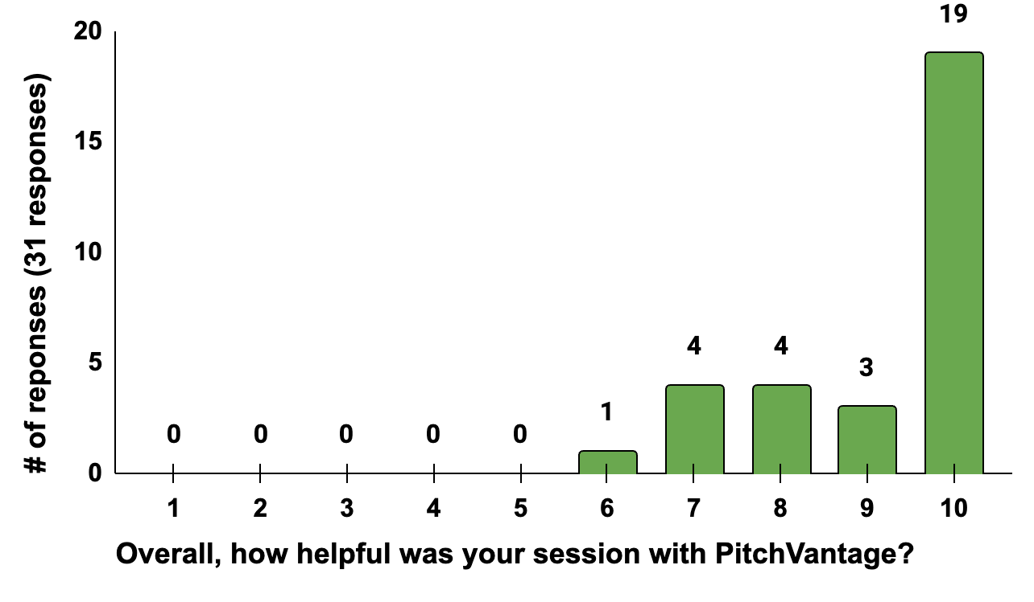

Figure 7. Anonymous survey responses about the helpfulness of studio sessions.

In terms of how users engaged with the studio, most reported using multiple features to support their practice. As shown in Table 19, 78.6% practiced their presentation, and over 70% reviewed feedback on content, delivery skills, and body language. Additionally, users employed such features as transcript review (35.7%), video tutorials (35.7%), and playback of their recording (28.6%). This multi-modal engagement suggests that users not only rehearse but also reflect on their performance, using the studio as a space for iterative improvement.

Studio Functions | % of responses
Practiced my presentation | 78.6%
Reviewed my feedback for content | 71.4%
Reviewed my feedback for delivery skills | 71.4%
Reviewed my feedback for body language | 71.4%
Reviewed the transcript | 35.7%
Watched tutorials | 35.7%
Watched my recording | 28.6%
Table 19. Use of different functions in the studio sessions based on survey results.

When asked which components of the session were most useful (Table 20), respondents highlighted the feedback features. While practicing the presentation was assumed, users pointed to overall feedback (35.7%), delivery skills (21.4%), body language (14.3%), content feedback (14.3%), tutorials (14.3%), and transcript review (14.3%) as particularly helpful. These responses reinforce the idea that users value both the rehearsal and the reflective feedback cycle enabled by the studio.

Functions | % of responses
Overall feedback | 35.7%
Feedback on the body language | 14.3%
The feedback on delivery skills | 21.4%
The content feedback | 14.3%
Video tutorials | 14.3%
The transcript | 14.3%
Table 20. Most useful components of studio sessions based on survey results.

Qualitative comments, presented in Table 21, further support the studio’s effectiveness. Users described the feedback as “detailed,” “accurate,” and “comprehensive,” with several noting that the AI-generated insights were “surprisingly objective” and “on point.” One user remarked that the studio provided a “very user-friendly way to review my speech,” while another emphasized its value in identifying areas for future improvement. These comments suggest that the studio offers a meaningful complement to instructor-led consultations by providing structured, low-pressure opportunities for rehearsal and self-assessment.

Selected feedback | Information about the users
“I was surprised by how well the software was able to analyse me and give very detailed feedback that was also correct in terms of my subject theoretically.” | a Ph.D. student, School of Science
“I was especially blown away by what the Oral Communication Studio could do. All the advice was right on point and provided a very user-friendly way to review my speech.” | Master’s student, School of Humanities and Social Sciences
“The public speaking studio was really good! I have been recommending it to other people from my department.” | a Ph.D. student, School of Science
“The studio sessions gave a comprehensive evaluation across many aspects of my talk. While some of the feedback was daunting, it highlighted important areas for future improvement.” | a Ph.D. student, School of Science
“I was actually blown away by the AI and how useful it was to point out things in my feedback. It also was very objective (humans always try to be more polite :))” | Master’s student, School of Management
Table 21. Selected user feedback about the studio sessions

While most feedback was positive, a few users noted limitations. Some found the body language assessment inaccurate, especially in cases where eye movement was scored lower for not aligning with the camera. Others reported difficulty downloading comments or found the tutorials less effective. However, 36% of respondents explicitly stated that they saw no drawbacks and were very satisfied with the experience.
Finally, the survey asked whether users planned to follow up with a WCC instructor (Table 22). A majority (64.3%) expressed interest in doing so, with 35.7% indicating definite interest and 28.6% expressing tentative interest. Only 35.7% were not interested in scheduling an instructor-led session. This suggests that while users value the autonomy and flexibility of the studio, many also see it as a complementary resource that prepares them for or leads naturally into more personalized instructor-led support.

Are you planning to schedule a follow up session with a WCC Lecturer? | % of responses
Yes | 35.7%
Maybe | 28.6%
No | 35.7%
Table 22. Studio survey responses regarding follow-up instructor-led sessions.
In sum, 97% of users reported high satisfaction with the feedback provided by the studio software, and 64.3% also indicated some interest in scheduling follow-up sessions with WCC instructors. This finding suggests that self-guided practice enables users to rehearse and refine their presentations, while also encouraging them to engage in personalized, instructor-led coaching. The studio therefore functions not as a replacement for instructor-led consultation, but as a complementary resource.

Discussion
The results of this study demonstrate that instructor-led consultations and self-guided studio sessions serve distinct but complementary roles in supporting oral communication development.

Demographic of the Users
First, instructor-led consultations and self-guided studio sessions vary in the demographic of their users. Research professionals, comprising approximately 24% of oral communication sessions, engaged less with the self-guided studio (14%). Postdoctoral scholars showed a stronger preference for oral communication support, accounting for a higher proportion of oral-focused consultations than general ones (13% vs. 9%), and favored
self-guided sessions over instructor-led formats (22% vs. 13%). Graduate students, who represent the majority of users seeking communication support (54% of all consultations), scheduled slightly more self-guided practice sessions than instructor-led ones (61% vs. 54%). In contrast, undergraduate students used consultations for oral communication less frequently than for other types of projects (8% vs. 16%) and made minimal use of the self-practice studio (3%).
These patterns likely reflect differences in the frequency and intensity of oral communication demands across academic roles. Subgroups with more frequent presentation requirements appear to seek out more opportunities for structured practice. The studio, in particular, offers a flexible platform for repeated rehearsal, which may be especially valuable for those navigating high-stakes or recurring oral communication tasks.
Additional demographic patterns further show how different user groups engage with oral communication support. Female clients participate in oral communication sessions more frequently than male clients (56% vs. 41%) and make greater use of self-guided studio sessions (61% vs. 37%). Users identifying with other genders represent a very small proportion of total sessions and do not substantially alter the overall distribution.
Neurodiverse users schedule slightly fewer oral communication sessions than other types of consultations (2.9% vs. 4.2%) and show no significant preference between
instructor-led and self-guided formats, suggesting a balanced engagement across modalities.
The most striking variation emerges in relation to language proficiency. Non-native English speakers account for the vast majority of instructor-led oral communication sessions (71%), while native speakers and multilingual users comprise only 14% and 15%, respectively. However, this pattern shifts in the context of self-guided studio use: native speakers and multilingual users increase their participation to 25% and 34%, respectively. This shift may reflect differences in self-efficacy, comfort with autonomous practice, and perceived need for individualized feedback. While non-native speakers may seek more structured, instructor-led support, native and multilingual users may feel more confident navigating oral practice independently.

Projects Discussed by the Users

The second major difference lies in the projects discussed during instructor-led and self-guided projects. In instructor-led sessions, research professionals and postdoctoral scholars primarily used oral communication consultations to prepare for conferences and other professional presentations (58%), with additional focus on pronunciation practice (25% and 28%) and teaching-related presentations (16% and 13%, respectively). Graduate students showed a slightly different pattern, allocating fewer sessions to professional presentations (41%) and more to pronunciation practice (37%) and class presentations (22%), though it remains unclear whether these reflect teaching or coursework. Undergraduate students exhibited the most distinct usage profile. Only 21% of their sessions focused on professional presentations, while a larger share addressed class assignments (37%) and pronunciation and conversational fluency (31%). Interestingly, 10% of their consultations involved developing ideas for presentations, a substantially higher rate than in any other group where developing ideas ranged from 0–1%.

In self-guided studio sessions, users mostly come to practice their presentations and review their content, delivery and body language feedback, analyze their transcript and watch their recording. They cannot brainstorm ideas or practice conversation for fluency there. The most frequent genres, 34%, are research presentations for their lab or department. Other genres include public speaking presentations (24%), class presentations (14%), conference talks (8.5%), job interviews (8.5%), and others.

These findings suggest that instructor-led consultations and self-guided studio sessions may support different goals of oral communication development. Instructor-led sessions are used for ideation, conceptual framing, and nuanced feedback, especially by users preparing for complex and high-stakes presentations. In contrast, self-guided studio sessions are primarily used for rehearsal and refinement, offering a venue for practicing delivery and analyzing performance.

Another important observation is that studio users typically practiced one project per session, while 30% of instructor-led consultations addressed more than one topic during sessions. This trend suggests that users may want to maximize instructor’s help during a session, while relying on the studio for repeated and focused rehearsal of one project.

At last, but not least, the nature of the intended audience might also play a role in the modality choice. Instructor-led sessions more often centered on presentations for expert audiences, such as principal investigators, course instructors, admissions committees, and search committees, where tailored feedback is critical. In contrast, self-guided sessions were more frequently used to prepare for public-facing presentations, including interdisciplinary talks and general audience events. These types may include formats like three-minute thesis competitions, which can be highly stressful and demand extensive rehearsal, making the studio an ideal resource for numerous practices.

Themes Discussed During Sessions

The final difference is in the themes discussed during sessions. The analysis of the themes discussed during instructor-led consultations highlighted four, Rhetorical Situation, Content Development, Visual Communication, and Delivery and Practice, that were frequently repeated during oral communication consultations. Within these themes, the themes that received most attention, which I randomly cut at 20% or more of sessions, are listed in the left part of Table 23.

Topics frequently discussed during sessions | % of sessions | Topics occasionally discussed during sessions | % of sessions | Topics rarely discussed during sessions | % of sessions
Audience Awareness | 25% | Framing: Opening/ Conclusion | 10% | Transitions | 8%
Genre Expectations & Conventions | 24% | Figures/ Graphs/Visuals | 9% | Jargon & Technical Vocabulary | 5%
Argument, Evidence & Support | 22% | Grammar & Language Accuracy | 13% | Eye Contact | 1%
Organization/ Structure | 20% | Word Choice & Clarity | 16% | Body Language | 3%
PPT Slides & Design | 27% | Concision | 10% | Time Management | 7%
Rehearsal/ Preparation | 24% | Intonation | 14% | Nervousness/ Anxiety | 5%
Fluency | 22% |  |  | Confidence | 4%
Pronunciation | 26% |  |  | Comprehension/ Listening | 4%
Table 23. Frequently, occasionally, and rarely discussed topics during instructor-led sessions.
The two themes, Language Clarity & Style and Engagement & Self-Management, received less attention. The categories of Transitions and Jargon & Technical Vocabulary in the Language Clarity & Style and all six categories in the Engagement & Self-Management occurred in 8% or fewer of the consultations, as illustrated in Table 23 (right part).
Interestingly, most of the frequently addressed topics are not and cannot be addressed in the studio sessions since AI-powered revision algorithms cannot provide sufficient feedback on the rhetorical situation, or the argument validity, or the depth of the evidence since they do not have information about the presenter’s audience and purpose. It also does not provide feedback on the conversation fluency or pronunciation. At the same time, the PitchVantage software addresses most of the topics that are rarely addressed in instructor-led consultations. For example, in its analysis of the content, the studio software provides detailed feedback on transitions and jargon/ technical vocabulary. It also offers substantial feedback on the presenter's gesturing, body language, and eye contact. The repeated practicing with timed sessions and the in-built tutorials also help studio users address time management during their presentations, build confidence, and gradually conquer nervousness and anxiety.
Furthermore, some of the topics are addressed by both instructor-led and studio sessions, listed in the middle column of Table 23. Thus, the users may benefit from both modalities to receive feedback on introductions and conclusions, word choice and phrasing, concision and vocal delivery.
Therefore, the two modalities form a complementary system. Instructor-led sessions support strategic planning and rhetorical framing, while studio sessions enable iterative rehearsal and performance refinement. Users benefit from the opportunity to first clarify their communicative intent and structure with an instructor, and then reinforce delivery and confidence through self-guided practice. They can then polish their presentations with the instructor again if their timeline and consultation schedule allow that.
The complementarity between the two types of consultations should further eliminate fears that self-guided sessions substitute in-person consultations. Instead, studio sessions extend the center’s reach to individuals who might not initially seek in-person support. For many users, self-guided sessions become an entry point that encourages deeper engagement with the center’s human-led services.
The two modalities not only complement each other, but also boost the general support in oral communication. This idea is supported by the consultation data showing that the percentage of instructor-led oral communication sessions more than doubled from an average of 4.7% in prior years to 11.2% during the year when the studio was launched. This increase addresses frequent administrators’ concern that self-guided technologies might lead to declining consultation numbers or diminish the value of instructor-led support.
Another administrators’ concern is related to users’ overreliance and dependency on AI-supported systems. In this respect, it is important to distinguish the studio from Gen AI tools. The studio requires meaningful learner effort: users schedule a session, rehearse their presentation, and actively engage with feedback. Gen AI, by contrast, offers a more passive form of reliance in which a prompt yields immediate text or analysis with minimal cognitive engagement.
In addition, the use of AI-powered tools is accompanied by broader ethical concerns. Since such systems are trained on large datasets, they inevitably reflect the linguistic, cultural, and rhetorical norms embedded in those datasets. As a result, the software may privilege certain delivery styles or communicative behaviors as markers of “effective” speaking, even when those norms are not universal or appropriate for all communicative contexts. These limitations further highlight the importance of instructor-led consultations, where consultants can help students interpret automated feedback critically, contextualize it within disciplinary and cultural expectations, and resist assumptions about what “good” speaking entails.
To help students develop a more critical stance toward the software’s feedback and to highlight the limitations of AI-powered software, we added a disclaimer posted below the studio screen:
“The studio is designed to supplement instructor feedback by providing an objective and detailed overview of ways to improve your public speaking and presentation skills. The feedback you receive can serve as guidance to help you identify areas for refinement and to support your development as a presenter. The scoring and feedback provided in the PitchVantage report are generated by an AI program and may not be 100% consistent or accurate. Please interpret the results with discretion and discuss any questions with your instructor.”

The findings of this paper reveal a distinction between the two modes: while studio sessions offer flexibility and autonomy, instructor-led consultations foster deeper engagement, personalized feedback, and rhetorical awareness. This contrast underscores the pedagogical limits of AI-enhanced tools and the enduring value of human interaction in writing support. As Essid (2023) argues, writing and communication center specialists provide expertise in areas that remain beyond the reach of Gen AI, including promoting metacognition, practicing active listening, and guiding ethical source use (p. 45). These dimensions are not easily replicated by software, no matter how sophisticated, and they highlight why studio tools should be viewed as supplements rather than substitutes.

Conclusion
This study demonstrates that instructor-led consultations and self-guided studio sessions serve distinct but complementary roles in supporting oral communication development. Rather than viewing technology and AI-powered tools as threats to the existence of communication centers, we should consider them as tools to extend our reach, diversify our offerings, and meet students where they are. The Oral Communication Studio, as explored in this study, exemplifies how interactive software can support learners in a less time-constrained fashion, foster agency, and even encourage deeper engagement with instructor-led consultations. When thoughtfully integrated, these tools do not replace human support, but rather amplify it.
Students like Marley no longer need to stare at the blinking cursor on their screen. Marley has drafted, rehearsed, and refined her pitch through the layered support of instructor-led consultations and practiced it with self-guided technology. The communication center became a process that helped her grow.

Statement on the Use of Generative AI

Generative AI tools (Copilot and Chat GPT 4o) were used during the editing and proofreading stage of the first draft of this manuscript to receive suggestions for clarity, coherence, and wording. All suggestions were reviewed and verified by the author, who bears full responsibility for the accuracy and integrity of the final manuscript. No Gen AI tools were used to generate original content, analysis, or interpretations. No AI tools were used during further revision of the manuscript.

References
Bridwell-Bowles, L., Powell, K. E., & Choplin, T. W. (2009). Not just words any more: Multimodal communication across the curriculum. Across the Disciplines, 6(2), 1-28.
Clemson University. (n.d.). Communication Center. https://www.clemson.edu/cbshs/departments/communication/centers/communication-center.html
Cronin, M. W., Grice, G. L., & Palmerton, P. R. (2000). Oral communication across the curriculum: The state of the art after twenty-five years of experience. Journal of the Association for Communication Administration, 29(1), 66–87.
Digital Education Council. (2024, August 2). Global AI Student Survey 2024. https://www.digitaleducationcouncil.com/post/digital-education-council-global-ai-student-survey-2024
Dwyer, K. K., & Davidson, M. M. (2012). Speech center support services, the basic course, and oral communication assessment. Basic Communication Course Annual, 24(1), 9.
Eastern Kentucky University. (n.d.). Noel Studio. EKU. Retrieved November 29, 2025, from https://www.eku.edu/in/noel-studio/
Ellis, J. B., & Stuart, E. (2021). The Science behind Learning: Practical Applications of Curiosity, Sociality, and Emotion in Communication Center Consultations. Communication Center Journal, 7(1), 3-13.
Essid, J. (2023) "Writing Centers & the Dark Warehouse University: Generative AI, Three Human Advantages," Interdisciplinary Journal of Leadership Studies: Vol. 2, Article 3. Available at: https://scholarship.richmond.edu/ijls/vol2/iss2/3
Essid and Cummins (2024) A Future for Writing Centers? Generative AI and What Students are Saying. The Peer Review, 9.2.
Fathi, J., Rahimi, M., & Derakhshan, A. (2024). Improving EFL learners’ speaking skills and willingness to communicate via artificial intelligence-mediated interactions. System, 121, 103254. https://doi.org/10.1016/j.system.2024.103254
Hidayatullah, E. (2024). The impact of Talkpal.AI on English speaking proficiency: An academic inquiry. Journal of Insan Mulia Education, 2(1), 19–25. https://doi.org/10.59923/joinme.v2i1.98
Harahap, A. P., & Dalimunthe, A. A. (2024). Improving Junior High School Students English Speaking Skills Using the Speechace Application. IDEAS: Journal on English Language Teaching & Learning, Linguistics & Literature, 12(2).
Jones, A., Hunt, S., Simonds, C., Comadena, M., & Baldwin, J. (2004). Speech laboratories: An exploratory examination of potential pedagogical effects on students. Basic Communication Course Annual, 16, 105–138.
LeFebvre, L., & LeFebvre, L. (2014). The communication center at U.S. colleges and universities: A descriptive overview. Basic Communication Course Annual, 26, Article 13. https://ecommons.udayton.edu/bcca/vol26/iss1/13
Lindberg, N., & Domingues, A. (2024). Report on AI chatbots’ impact on writing centers. Unpublished.
Louisiana State University. (n.d.). Communication Studio | LSU College of Engineering. https://www.lsu.edu/eng/chevron/geauxcommunicate.php
Martin, J. C., Apostel, S., Strawser, M. G., & Martin, F. (2017). The Communication Center as a Transcendent Physical and Virtual Space. Communication Center Journal, 3(1), 61-77.
McDermott, V. (2022). The Value of Communication Centers in Professional Organizations: A Former Communication Center Coach Working at NASA. Communication Center Journal, 8(1), 3-17.
Mutsvairigwa, P., Mhlongo, N., Shabangu, N., Zwide, S., Nomxoko, N., & Mbhele, N. (2024, December). Writing Centre Consultations in the Age of Artificial Intelligence: Perspectives from tutors at a selected University of Technology in KZN. In The Focus Conference (TFC 2024) (pp. 533-545). Atlantis Press. https://www.atlantis-press.com/proceedings/tfc-24/126007662
National Association of Communication Centers. (n.d.). Directory of Communication Centers. Retrieved November 29, 2025, from https://commcenters.org/resources/directory-of-centers
Nicol, D., & Kushwah, L. (2024). Shifting feedback agency to students by having them write their own feedback comments. Assessment & Evaluation in Higher Education, 49(3), 419-439
Turner, K. J., & Sheckels, T. F. (2015). Communication centers: A theory-based guide to training and management. Bloomsbury Publishing PLC.
Yook, E. L., & Atkins-Sayre, W. (2012). Communication centers and oral communication programs in higher education: Advantages, challenges, and new directions. Bloomsbury Publishing PLC.
Yook, E. L., & Kim, M. M. (2013). Reflecting on assessment results to inform communication center tutor training and hiring. Journal of Assessment and Institutional Effectiveness, 3(2), 140-156. https://doi.org/10.5325/jasseinsteffe.3.2.0140
Zhao, X., Cox, A., Chen, X., & Coleman, B. (2024). A report on the use and attitudes towards generative AI among disabled students at the University of Sheffield Information School.

