
JOURNAL OF EFFECTIVE TEACHING IN HIGHER EDUCATION
Vol. xx, No. x, 2026
https://doi.org/xxxxxxxxxxxxxxxx
Peer-Reviewed Article

This is Where a Title Will Go
ABSTRACT
Your abstract should between 150 and 250 words in length. This sample abstract text is 175 words. The abstract text will go here. This is sample abstract text that is copied over and over again. Your abstract should between 150 and 250 words in length. This sample abstract text is 175 words. The abstract text will go here. This is sample abstract text that is copied over and over again. Your abstract should between 150 and 250 words in length. This sample abstract text is 175 words. The abstract text will go here. This is sample abstract text that is copied over and over again. Your abstract should between 150 and 250 words in length. This sample abstract text is 175 words. The abstract text will go here. This is sample abstract text that is copied over and over again. Your abstract should between 150 and 250 words in length. This sample abstract text is 175 words. The abstract text will go here. This is sample abstract text that is copied over and over again.
KEYWORDS
Keyword 1, keyword 2, keyword 3, keyword 4, keyword 5

*Please make sure to remove all identifying information from this document. Please use [Redacted] as a placeholder for all identifying information (i.e. author names and institutions). Please be sure to click “Remove all personal information from this file on save” in the document privacy settings (Review > Protect > Protect Document > Privacy).
Begin main text of the article here. All articles submitted for consideration in JETHE should include an opening section that articulates a clear purpose and demonstrates how and why the subject will be compelling to JETHE’s audience. Do not include an introduction heading to start this section. Your first heading level should come immediately after the introduction section of your article. Please follow all formatting guidelines listed below
In this section, you can see what sample body text and sample headings look like and how they’re formatted. Sample Heading formats are listed below. You can copy and paste them as needed. Delete the sample headings before submitting your final column.

Heading Level 1
Text after Heading Level 1 begins as a new paragraph. This is sample body text. This is more sample body text. And more. This is sample body text. This is more sample body text. This is yet even more sample body text. And more. Text after Heading Level 1 begins as a new paragraph. This is sample body text. This is more sample body text. This is yet even more sample body text. And more.

Heading Level 2
Text after Heading Level 2 begins as a new paragraph. This is sample body text. This is more sample body text. This is yet even more sample body text. And more. This is sample body text. This is more sample body text. This is yet even more sample body text. And more. Text after Heading Level 2 begins as a new paragraph. This is sample body text. This is more sample body text. This is yet even more sample body text. And more.

Heading Level 3
Text after Heading Level 3 begins as a new paragraph. This is sample body text. This is more sample body text. This is yet even more sample body text. And more. This is sample body text. This is more sample body text. This is yet even more sample body text. And more. Text after Heading Level 3 begins as a new paragraph. This is sample body text. This is more sample body text. This is yet even more sample body text. And more.

Heading 4. Text after Heading Level 4 begins on the same line. This is sample body text. This is more sample body text. This is yet even more sample body text. And more. This is sample body text. This is more sample body text. This is yet even more sample body text. And more. Text after Heading Level 4 begins on the same line. This is sample body text. This is more sample body text. This is yet even more sample body text. And more.

Heading 5.
Text after Heading Level 5 begins on the same line. This is sample body text. This is more sample body text. This is yet even more sample body text. And more. This is sample body text. This is more sample body text. This is yet even more sample body text. And more. Text after Heading Level 5 begins on the same line. This is sample body text. This is more sample body text. This is yet even more sample body text. And more.

Table and Figure Formatting
In this section, you can see examples of tables and figures. Whenever including tables and figures, adhere to the formatting guidelines found in the APA 7 manual, or visit APA Style: Tables and Figures.
Table 1
Overall Student Satisfaction with Learning Management System
Feature | Very unsatisfied | Unsatisfied | Neutral | Satisfied | Very satisfied
Ease of use | 5 | 3 | 15 | 20 | 57
Wait time | 1 | 2 | 9 | 13 | 75
Intuitiveness | 4 | 4 | 12 | 35 | 45
Overall satisfaction | 3 | 3 | 12 | 24 | 58
Note. 100 students were surveyed.
Figure 1
Student Satisfaction with Ease of Use of Learning Management System
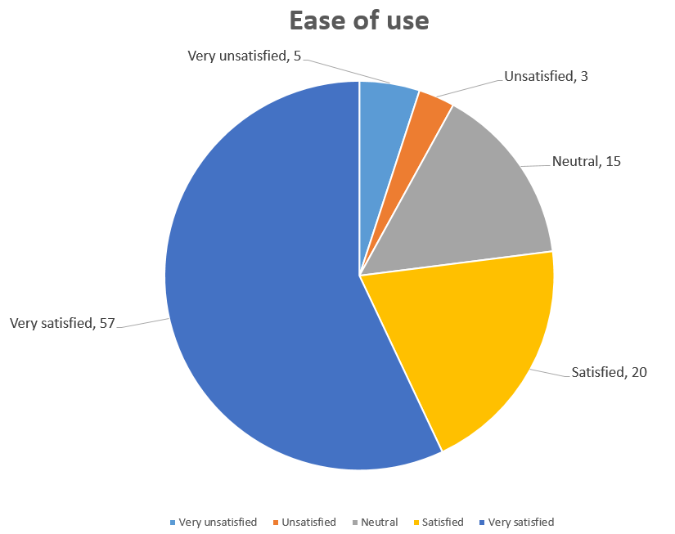
Note. 100 students were surveyed.

Block Quotations
Use block quotations for direct quotes that are made up of 40 words or more. Block quotations don’t use quotation marks, but rather they start on a new line and the whole block of text is indented by 0.5 in. If the quotation contains additional paragraphs, indent the first line of each extra paragraph an additional 0.5 in. For more information about formatting and citing block quotations, view the APA 7 manual or visit APA Style: Quotations. The example below showcases APA 7 block quote formatting:
In order to accurately estimate whether people are likely to form positive or negative expectations on any given occasion, it is necessary to go beyond simply considering chronic individual differences and identify the factors that make people more likely to form expectations in line with one bias or the other.
The present research sheds light on this issue by identifying a crucial distinction in the operation of these two train biases in expectation formation. Specifically, people’s valence weighting biases and self-beliefs about the future appear to shape expectations via qualitatively distinct processes. (Niese et al., 2019, p. 210)

References
Test, M. (2013). All references should use APA 7 citation style. The Journal of Sample References, 6(2). 133-158. https://doi.org/testdoi1234

*Please use [Redacted] as a placeholder for all references by the author(s).

Appendix

This is a sample footnote.

