University of North Carolina Asheville
Journal of Undergraduate Research
Asheville, North Carolina
Spring 2024
Physiological Comparison of Pure American and Hybrid American-Chinese Chestnut Hybrids
Sam Cleary
Biology Department
The University of North Carolina Asheville
One University Heights
Asheville, North Carolina 28804 USA
Faculty Mentors: Jonathan Horton, Camila Filgueiras
Abstract:
The American chestnut (Castanea dentata [Marsh.] Borkh.), once a dominant canopy species in eastern North America, fell victim to invasive pathogens in the early 20th century. The American Chestnut Foundation (TACF) spearheads restoration efforts using backcrossed hybrids with Chinese chestnut (Castanea mollissima Blume) for pathogen resistance. To understand how backcrossed chestnut hybrids (BC1F1 with 75% American genotype and BC3F3 with 94% American genotype) perform compared to pure American chestnut, this study investigated their photosynthetic capabilities and water relations in western North Carolina. Photosynthetic capacity was compared among these three chestnut classes with steady-state light response curves. Dark respiration rates, quantum yield, and maximum photosynthetic rates differed among the three chestnut types, but these did not result in differences in light compensation point, a measure of shade tolerance. In July and August, plant water potential was measured at predawn, morning and afternoon, and leaf gas exchange was assessed in the morning and afternoon under ambient conditions. Blight effects on the 100% stand resulted in small, shrubby plants that differed in size and light environment, so diurnal measurements were only taken in the two hybrid stands. Soil moisture and pre-dawn water potential were generally similar between the two stands, however, there were significant differences in daily gas exchange and water potential, with the 75% American chestnuts generally having higher rates of gas exchange in the afternoon, while also experiencing lower plant water potential and a greater change between pre-dawn and afternoon water potential. These results suggest that the 75% American chestnuts may be better able to perform under moderate atmospherically-induced water stress in the afternoon. Quantifying relationships between water relations, gas exchange, and environmental factors will allow us to evaluate long-term performance and inform robust planting site selection and management practices.

Introduction
American chestnut (Castanea dentata (Marshall) Borkh), played a major ecological and cultural role in eastern North America for centuries prior to the introduction of two non-native pathogens. Prior to pathogen introductions, chestnut was both widespread and dominant, found in upland forests throughout the eastern United States and Canada, occupying up to 25% of the canopy in the Appalachian Mountains. Its dominance and contribution to ecosystem structure and function rendered it a foundation species of the region's ecosystem (Smith 2000, Ellison et al. 2005). All parts of the chestnut provided necessary resources for many animals (e.g., habitat, leaf herbivory, and nut production) (Paillet 2003). Chestnut's broad canopy presence also contributed to a dense, diverse understory, with a variable light environment. Chestnut’s unique carbon to nitrogen ratio had large impacts on the soil chemistry and nutrient cycling on the forest floor, contributing as a long-term carbon sink (Schwaner et al. 2019). Culturally, American chestnut was highly valued for its rapid, straight growth, leading to major use of the lumber in construction, furniture making, and firewood, as well as a major food source to Appalachian communities (Davis 2005).
American chestnut suffered a dramatic decline in the early 20th century due to the introduction of the fungal pathogen Cryphonectria parasitica (Murrill), chestnut blight. The blight was first detected in New York City around 1904, likely originating from imported Japanese chestnut (Castanea crenata (Siebold & Zucc.)) nursery stock. The chestnut blight infiltrates the bark and cambium of chestnuts, disrupting the vascular system and girdling the tree through secretion of virulence factors and oxalate (Anagnostakis 1987). The resultant cankers cause wilting and eventual death. Chemical pathogen treatments and removal of infected trees failed to prevent the spread. Chestnut blight spreads easily through spores that are dispersed by wind and animals. By 1950 it had spread throughout the entire chestnut range infecting 80% of trees (Scharf et al. 1981, Henderson et al. 2023). This introduced pathogen resulted in near-complete decimation of the American chestnut population, with only scattered individuals persisting. Consequently, forest composition shifted dramatically, favoring oaks in the canopy. Phytophthora root rot (Phytophthora cinnamomi (Rands)), a pathogen affecting seedlings, arrived in the late 18th to early 19th century. This pathogen limits seedling establishment and is a barrier to the reintroduction of chestnut. Phytophthora occurs most commonly in low elevation areas of the southeastern U.S., where soils have high clay content and temperatures are warm to moderate, as phytophthora does not tolerate freezing soil, and is a major problem in the southern Appalachian Mountains.
In an effort to reintroduce the chestnut to its historic range The American Chestnut Foundation (TACF) initiated a backcross breeding program in 1989 with the aim of restoring the American chestnut to the canopy within its original geographical range (Sniezko 2006). Central to this program is the use of hybridization with the blight resistant Chinese chestnut (Castanea mollissima Blume). This was followed by multiple backcrosses with American chestnut to generate trees with 94% American chestnut genome, blight resistance from the 6% Chinese chestnut genes, and trees possessing traits like the pure American chestnuts. These third backcross (94% American genome) generation trees were then bred with each other to further promote the physical form and attributes of American chestnut, and the third generation of these, BC₃F_{3,} is targeted for reintroduction (Hebard 2005).
In addition to morphological similarities, reintroduced chestnut hybrids should have comparable physiological characteristics. Chestnuts are highly adaptable to variable light environments. They can persist in low-light conditions but also rapidly exploit canopy openings to fill gaps with new growth (Wang et al. 2006; Joesting et al. 2007, Rhoades et al. 2009; Clark et al. 2023,). While hybrids have been shown to have similar similar photosynthetic characteristics to American chestnuts (Knapp et al. 2014), their responses to water stress are intermediate between American and Chinese chestnuts (Fredericksen et al. 2021). However, these studies were conducted on seedlings and/or in controlled settings, and field studies are needed to further our knowledge of backcross hybrid physiology and how they might respond when out-planted into intact forests (Diskin et al. 2006, Pinchot et al. 2015). We had the opportunity to study three of these accessions, including BC₁F₁ (75%) trees, BC₃F₃ (94%), and pure American chestnut trees in a forest setting. For reintroduction to be successful, the new blight-resistant hybrids should have the same ecological characteristics of the pre-blight chestnut (Sniezko 2006). We expected steady state photosynthesis and water use of the 94% to be similar to 100%, and to perform well in forest settings, where American chestnut was once dominant.

Methods

Study sites
Three populations of chestnut trees were used for this study, located within Dupont State Recreational Forest (DSRF) in Western North Carolina. The 100% stand was planted in 2012 from seeds collected along the Blue Ridge Parkway in NC, the 94% stand was planted in 2014 and the 75% in 2009 from seedlings obtained from TACF. All three stands were within 1 km of each other and experienced similar weather conditions as monitored by WRCC RAWS Guion Farms weather station in DSRF. Despite their proximity and similar weather, there were differences in the light availability of the stands because of differences in site preparation before plantings; the 94% stand was clearcut before planting, the 75% and 100% being planted in small cleared patches within intact forests (75% in mixed Betula-Pinus, 100% in mixed Quercus). Before conducting any physiological measurements, all trees in each stand were assessed for height, diameter at breast height (dbh), and an evaluation of blight severity.

Steady-State Leaf Gas Exchange
Steady-state photosynthetic characteristics were assessed by constructing light response curves in July 2023, using two portable photosynthesis systems (Li-6400, LiCor Biosciences, Lincoln, NE). Measurements were taken on intact leaves from six trees in each stand that had similar sunlight exposure. Leaves were placed in the cuvette under controlled settings (1200 µmol m⁻² s⁻¹ 420 ppm CO₂, 65 ±10% relative humidity, and 22 ± 2º C leaf temperature) and allowed to equilibrate before logging data. Then light was decreased stepwise 1200, 1000, 800, 600, 400, 300, 200, 100, 50, 25,10 to 0 µmol m⁻² s⁻¹ with leaves being allowed to equilibrate to each new light level before data were logged. Measurements were obtained between 10 AM and 2 PM to optimize conditions for gas exchange. Light response curves were fit using equations from Marshall and Biscoe (1980) and Thornley and Johnson (1990) using a macro in MS Excel. Steady-state photosynthetic parameters including maximum net photosynthesis rate (P_{n} max), the maximum rate of net CO₂ assimilation by a plant under saturating light intensity; dark respiration (R_{d}), a measure of leaf maintenance respiration in the absence of light; quantum yield (QY), a measure of the efficiency by which light energy is used to fix carbon; and light compensation point (LCP), the light intensity at which the rate of photosynthesis equals the rate of cellular respiration, were calculated from these fit curves.

Diurnal Physiology Measurements
Diurnal physiological patterns were measured on 12 trees from the 75% and 94% stands that were paired based on similar height, dbh, low blight infection, and crown light exposure. The 100% stand was excluded from this analysis because of the different structure and light exposure resulting from the trees being top-killed by blight and resprouting in the seedling layer. Plant water potential (Ψ) was measured at 4 AM, 10 AM, and 2 PM using a Scholander-type Pressure Chamber (Scholander et al. 1964; PMS-1000, PMS Instruments, Albany, OR). We also calculated the change in water potential between predawn and morning/afternoon measurements. Leaf gas exchange was measured mid-morning (7:00 - 10:00 AM) and mid-afternoon (1:00 - 3:00 PM). All measurements were conducted on one stand per day on subsequent days each month (July 25th - 26th and August 16th - 17th) with similar weather conditions. Chamber conditions were set to each leaf’s ambient conditions at the time of measurement.

Data Analysis
Steady-state gas exchange parameters met the assumptions of normality and were compared among stands (100%, 94% and 75%) with ANOVA and Tukey post-hoc tests. Diurnal physiology data were compared by month and time of day individually, using non-parametric Kruskal-Wallis tests, because the data did not meet assumptions of normality. Where significant differences occurred between the two stands, explanatory linear regressions were performed in an attempt to understand mechanisms behind these differences. This included relationships between soil moisture and water potential, and leaf gas exchange response to soil water availability, water potential, and leaf-to-air vapor pressure deficit. Where there were significant regressions in both stands, the slopes were compared by using stand as a second independent variable in a two-way ANOVA (Andrade and Estévez-Pérez 2014) and testing the interaction term. All statistical analyses were conducted using SAS v 9.4.

Results

Light Response Curves
﻿The light response curves differed among the chestnut types (Figure 1). Maximum photosynthesis (Fig. 2A) was similar between the 100% and 94% stands but was significantly lower in the 75% stand% (F = 10.06, p = 0.002). Dark respiration was similar between the 75% and 100% stands but was significantly higher in the 94% (F= 9.53, p = 0.002; Fig. 2B). Quantum yield was significantly higher in the 94% stand than 100% stand with the 75% stand being intermediate between them (F= 4.9, p = 0.0231; Fig. 2C). There were no significant differences in light compensation point among the stands (Figure 2D).

Diurnal Measurements

July
Soil moisture was significantly higher in the 94% stand than the 75% stand (X² = 4.82, p= 0.028 (Table 1). July predawn Ψ was also significantly higher (less negative) in 94% stand (X² = 5.70, p= 0.002). Despite this, afternoon net photosynthesis (P_{n}) was significantly higher in the 75% stand (X² = 6.68, p= 0.01). July afternoon P_{n} and transpiration (E_{t}) both decreased significantly with decreasing stomatal conductance (g_{s}) but the slopes did not differ between stands (P_{n ,} F = 0.26 P = 0.6919, Figure 3A and E_{t ,} F = 0.67 p = 0.4237, Figure 3B).

August
Soil moisture and predawn Ψ did not differ significantly between stands (Table 2). However, mid-morning Ψ was significantly lower (X² = 4.16, p = 0.0415) in the 75% stand, but there were no differences in morning gas exchange parameters between the stands. Afternoon Ψ was significantly lower (X² = 8.22, p < 0.001) and the change in Ψ from predawn to mid-afternoon was significantly greater (X² = 5.36, p = 0.02) in the 75% stand. Despite these differences in water status, P_{n} (X² = 6.16, p = 0.013), g_{s} (X² = 5.33, p = 0.02), and E_{t} (X² = 8.33 p = 0.004) were all significantly higher in the 75% stand (Table 2). In August afternoon both stands experienced decreasing E_{t} with decreasing g_{s}, but the slopes of the explanatory regression lines did not differ (PM F = 1.07 p = 0.3126, Figure 4A). There was a decrease in P_{n} with decreasing g_{s} in the 94% stand, but not the 75% stand (Figure 4B). There was a significant reduction in g_{s} with increasing VPD in the 94% stand, but not in the 75% stand (Figure 5A). E_{t} also decreased with increasing VPD in the 94% stand, but not in the 75% stand (Figure 5B).

Discussion

Light Response Curves
Maximum net photosynthesis (P_{n} max) was similar between 100% and 94% stands and higher than the 75%, suggesting comparable photosynthetic capacity between 100% and 94%, the target for reintroduction, under optimal light conditions. These results are similar to the findings of Knapp et al. (2014). Interestingly, R_{d} was significantly higher in the 94% stand compared to both 75% and 100% stands. Thicker leaves often have higher area-based metabolic activity, leading to higher respiration rates. Knapp et al. (2014) did not find differences in specific leaf mass (leaf mass per unit area) between chestnut types, but this was not measured in our study. The 94% stand was established in a previous clearcut with a west-facing slope, so may have had higher light environment resulting in thicker leaves (Boardman 1977). QY was highest in the 94% stand, and lowest in the 100% stand with the 75% being intermediate between the two. This is interesting, because higher QY are typically associated with leaves in lower light levels, but we found the opposite. The 75% lower quantum yield could also be attributed to a higher percentage of Chinese chestnut genome in the 75% stand, which has been shown to have a lower QY than American Chestnut (Knapp et al, 2014). Despite the higher R_{d} in the 94% stand, the higher QY seemed to offset the higher respiration resulting in no difference in LCP between chestnut types.

Diurnal Physiology
Our diurnal physiological data suggest differing physiological responses to atmospherically-induced water stress between the 75% and 94% stands. In July afternoon, despite higher pre-dawn Ψ and soil moisture in the 94% stand, the 75% stand exhibited higher afternoon P_{n}, exhibiting a greater ability to maintain P_{n} under similar water status. With decreasing g_{s}, both stands experienced decreasing E_{t} and P_{n}, but the slopes did not differ. This similarity in relationships suggest that other factors that were not measured may be affecting P_{n} between stands. In August, no pre-dawn Ψ differences between stands were observed, but the 75% had lower morning and afternoon Ψ. There was a greater difference between pre-dawn and afternoon Ψ in the 75% stand, without significant negative effect on gas exchange. Despite these differences in afternoon water status, afternoon gas exchange (P_{n} , g_{s}, E_{t}) was significantly higher in the 75% stand. In the 94% stand, g_{s} significantly decreased with increasing VPD, leading to reductions in both P_{n} and E_{t.} In contrast, the 75% stand showed a decrease in E_{t} with declining g_{s} under high VPD, but P_{n} remained unaffected. This suggests distinctly different stomatal responses to increasing VPD between the two stands, explaining the observed differences in gas exchange.

The observed patterns suggest the 75% stand suggests a more anisohydric behavior, tolerating wider water potential fluctuations for gas exchange, while the 94% stand is more isohydric, prioritizing stable leaf water potential by closing stomata at higher VPD, even if it reduces gas exchange. Anisohydric plants use a riskier strategy prioritizing productivity by allowing more water loss, while isohydric plants prioritize survival by conserving water (Meinzer et al. 2017, Chen et al. 2021).

Our findings differ from Fredericksen et al. (2021), who documented contrasting water use strategies in American, Chinese, and hybrid chestnut types under controlled drought conditions. Hybrids displayed lower g_{s} than both parents but maintained higher water-use efficiency.
Frederickson's findings suggest that American chestnut is more anisohydric, but our findings found the 75% chestnut type was more isohydric than the 94% which had a lower percentage of genes from Chinese chestnut. There is likely genetic variation of this trait within the American and Chinese chestnut species. However, the trees used in our study are of unknown lineages. The discrepancy between our findings and those of Frederickson suggest that more research on the physiological characteristics of American chestnut and their hybrids are needed in a wider range of environmental conditions.

Acknowledgements
We would like to thank the American Chestnut Foundation for funding this study. We’d also like to thank Jordan Luff and DuPont State Recreational Forest support and Kat Brown, Evan Hausler, Jaq Reed, and Abi Levinson for field assistance.

Literature Cited
Anagnostakis SL. 1987. Chestnut Blight: The Classical Problem of an Introduced Pathogen. Mycologia. 79(1):23. doi:https://doi.org/10.2307/3807741.

Andrade, J.M., and M.G. Estévez-Pérez. “Statistical Comparison of the Slopes of Two Regression Lines: A Tutorial.” Analytica Chimica Acta, vol. 838, Aug. 2014, pp. 1–12, https://doi.org/10.1016/j.aca.2014.04.057.

Boardman NP. 1977. Comparative photosynthesis of sun and shade plants. Philosophical Transactions of the Royal Society of London. Series B, Biological Sciences. 279(999): 181–208.

Brown CE, Mickelbart MV, Jacobs DF. 2014. Leaf physiology and biomass allocation of backcross hybrid American chestnut (Castanea dentata) seedlings in response to light and water availability. Tree Physiology. 34(12):1362–1375. doi:https://doi.org/10.1093/treephys/tpu094.
Chen Z, Zhang Y, Yuan W, Zhu S, Pan R, Wan X, Liu S. 2021 Mar 9. Coordinated variation in stem and leaf functional traits of temperate broadleaf tree species in the isohydric-anisohydric spectrum. Tree Physiology. doi:https://doi.org/10.1093/treephys/tpab028.

Clark SL, Schlarbaum SE, Saxton AM, Jeffers SN, Baird RE. 2023. Eight-year field performance of backcross American chestnut (Castanea dentata) seedlings planted in the southern Appalachians, USA. Forest Ecology and Management. 532:120820. doi:https://doi.org/10.1016/j.foreco.2023.120820.

Davis, D.E. 2005. Historical significance of American chestnut to Appalachian culture and ecology. In, proc. of conf. on restoration of American chestnut to forest lands, Steiner, K.C. and J.E. Carlson (eds.).

Diskin M, Steiner KC, Hebard FV. 2006. Recovery of American chestnut characteristics following hybridization and backcross breeding to restore blight-ravaged Castanea dentata. Forest Ecology and Management. 223(1-3):439–447. doi:https://doi.org/10.1016/j.foreco.2005.12.022.

Ellison AM, Bank MS, Clinton BD, Colburn EA, Elliott K, Ford CR, Foster DR, Kloeppel BD, Knoepp JD, Lovett GM, et al. 2005. Loss of foundation species: consequences for the structure and dynamics of forested ecosystems. Frontiers in Ecology and the Environment. 3(9):479–486. doi:https://doi.org/10.1890/1540-9295(2005)003[0479:lofscf]2.0.co;2.

Fredericksen B, Kukor S, Rosenthal DM. 2021. Physiological changes in advanced hybrid chestnuts do not alter blight resistance under co-occurring drought. Canadian Journal of Forest Research. 51(11):1678–1687. doi:https://doi.org/10.1139/cjfr-2020-0505.

Hebard FV. 2005. The Backcross Breeding Program of the American Chestnut Foundation. Journal of the American Chestnut Foundation. 19.

Henderson AF, Santoro JA, Kremer P. 2022. Ensemble modeling for American chestnut distribution: Locating potential restoration sites in Pennsylvania. Frontiers in Ecology and Evolution. 10. doi:https://doi.org/10.3389/fevo.2022.942766.

Joesting HM, McCarthy BC, Brown KJ. 2007. The photosynthetic response of American chestnut seedlings to differing light conditions. Canadian Journal of Forest Research. 37(9):1714–1722. doi:https://doi.org/10.1139/x07-039.

Knapp BO, Wang GG, Clark SL, Pile LS, Schlarbaum SE. 2014. Leaf physiology and morphology of Castanea dentata (Marsh.) Borkh., Castanea mollissima Blume, and three backcross breeding generations planted in the southern Appalachians, USA. New Forests. 45(2):283–293. doi:https://doi.org/10.1007/s11056-014-9408-x.

Marshall B, Biscoe PV. 1980. A Model for C₃Leaves Describing the Dependence of Net Photosynthesis on Irradiance. Journal of Experimental Botany. 31(1):41–48. doi:https://doi.org/10.1093/jxb/31.1.41.

Meinzer, Frederick C, et al. “Stomatal Kinetics and Photosynthetic Gas Exchange along a Continuum of Isohydric to Anisohydric Regulation of Plant Water Status.” Plant Cell and Environment, vol. 40, no. 8, 1 Aug. 2017, pp. 1618–1628, https://doi.org/10.1111/pce.12970.

Paillet FL. 2002. Chestnut: history and ecology of a transformed species. Journal of Biogeography. 29(10-11):1517–1530. doi:https://doi.org/10.1046/j.1365-2699.2002.00767.x. ‌

Pinchot CC, Schlarbaum SE, Clark SL, Saxton AM, Sharp AM, Schweitzer CJ, Hebard FV. 2017. Growth, survival, and competitive ability of chestnut (Castanea Mill.) seedlings planted across a gradient of light levels. New Forests. 48(4):491–512. doi:https://doi.org/10.1007/s11056-017-9577-5.

Rhoades C, Loftis D, Lewis J, Clark S. 2009. The influence of silvicultural treatments and site conditions on American chestnut (Castanea dentata) seedling establishment in eastern Kentucky, USA. Forest Ecology and Management. 258(7):1211–1218. doi:https://doi.org/10.1016/j.foreco.2009.06.014.

Scharf CS, DePalma NK. 1981. Birds and mammals as vectors of the chestnut blight fungus (Endothia parasitica). Canadian Journal of Zoology. 59(9):1647–1650. doi:https://doi.org/10.1139/z81-228.

Schwaner GW, Kelly CN. 2019. American chestnut soil carbon and nitrogen dynamics: Implications for ecosystem response following restoration. Pedobiologia. 75:24–33. doi:https://doi.org/10.1016/j.pedobi.2019.05.003.

Smith DM. 2000. American Chestnut: Ill-fated Monarch of the Eastern Hardwood Forest. Journal of Forestry. 98(2):12–15. doi:https://doi.org/10.1093/jof/98.2.12.

Sniezko RA. 2006. Resistance breeding against nonnative pathogens in forest trees — current successes in North America. Canadian Journal of Plant Pathology. 28(sup1):S270–S279. doi:https://doi.org/10.1080/07060660609507384.

Thornley, M, and Ian R Johnson. Plant and Crop Modelling. Oxford University Press, USA, 1990.
Table 1. Mean (± 1 SE) of July diurnal physiological measurements comparing 75% and 94% stands. Significant differences between stands (p < 0.05) are denoted by different superscripts.

July AM | 75% | 94%
Soil Moisture % | 18.48 ± 1.33^{b} | 22.05 ± 1.01ª
VPD (kPa) | 0.70 ± 0.08 | 0.69 ± 0.05
PreDawn Ψ (MPa) | - 0.55 ± 0.05ª | - 0.38 ± 0.03^{b}
Ψ (MPa) | - 0.86 ± 0.09 | - 0.75 ± 0.04
∆ Ψ (MPa) | - 0.31 ± 0.09 | - 0.36 ± 0.04
P_{n} (µmol m⁻² s⁻¹) | 3.66 ± 0.61 | 5.21 ± 0.98
g_{s} (mol m⁻² s⁻¹) | 0.47 ± 0.21 | 0.33 ± 0.13
E_{t} (mmol m⁻² s⁻¹) | 1.91 ± 0.28 | 1.60 ± 0.27
July PM | 75% | 94%
VPD (kPa) | 1.56 ± 0.019 | 1.49 ± 0.13
Ψ (MPa) | - 1.55 ± 0.62 | - 1.52 ± 0.8
∆ Ψ (MPa) | - 0.55 ± 0.049 | - 0.38 ± 0.03
P_{n} (µmol m⁻² s⁻¹) | 11.79 ± 1.52ª | 7.59 ± 1.33^{b}
g_{s} (mol m⁻² s⁻¹) | 0.16 ± 0.029 | 0.14 ± 0.04
E_{t} (mmol m⁻² s⁻¹) | 2.46 ± 0.39 | 1.89 ± 0.39

Table 2. Mean (± 1 SE) of diurnal physiological measurements comparing 75% and 94% stands. Significant differences between stands (p < 0.05) are denoted by different superscripts.

August AM | 75% | 94%
Soil Moisture % | 17.57 ± 1.4 | 16.92 ± 2.14
VPD (kPa) | 0.59 ± 0.02 | 0.56 ± 0.03
PreDawn Ψ (MPa) | - 0.45 ± 0.04 | - 0.4 ± 0.03
Ψ (MPa) | - 0.9 ± 0.08^{A} | - 1.27 ± 0.57^{B}
∆ Ψ (MPa) | - 0.45 ± 0.1 | - 0.88 ± 0.58
P_{n} (µmol m⁻² s⁻¹) | 3.86 ± 0.82 | 3.36 ± 0.45
g_{s} (mol m⁻² s⁻¹) | 0.16 ± 0.03 | 0.31 ± 0.15
E_{t} (mmol m⁻² s⁻¹) | 0.92 ± 0.12 | 1.19 ± 0.29
August PM | 75% | 94%
VPD (kPa) | 1.24 ± 0.06 | 1.25 ± 0.13
Ψ (MPa) | - 1.92 ± 0.06^{B} | - 1.00 ± 0.36^{A}
∆ Ψ (MPa) | - 1.47 ± 0.08^{A} | - 0.6 ± 0.36^{B}
P_{n} (µmol m⁻² s⁻¹) | 10.65 ± 1.00^{A} | 6.52 ± 0.7^{B}
g_{s} (mol m⁻² s⁻¹) | 0.17 ± 0.02^{A} | 0.09 ± 0.02^{B}
E_{t} (mmol m⁻² s⁻¹) | 2.13 ± 0.21^{A} | 1.14 ± 0.17^{B}

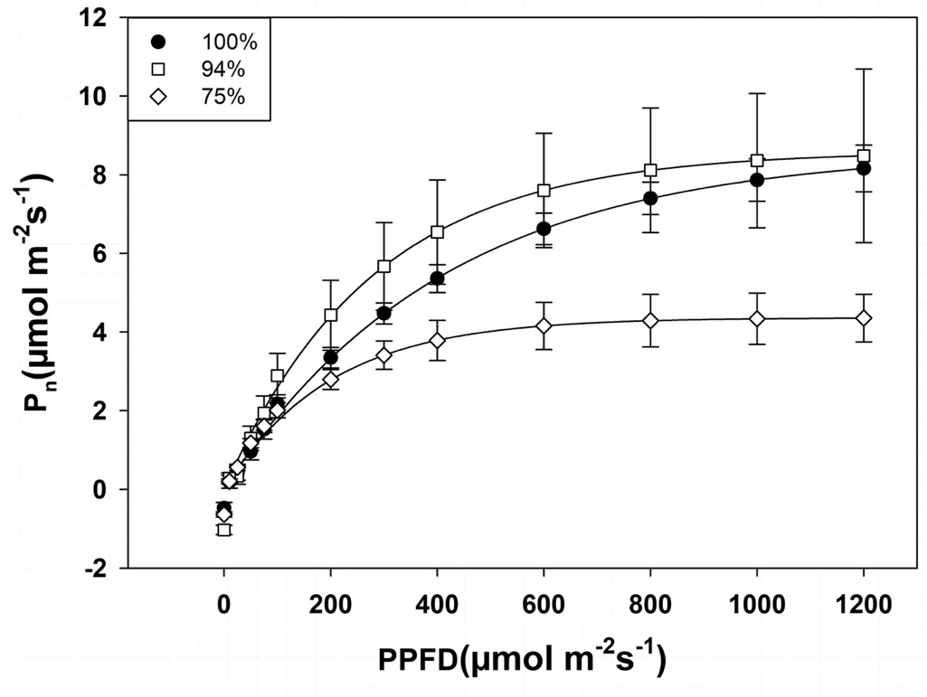

Figure 1: Steady-state light response curves for 100, 94%, and 75% stands. Points represent mean (± 1 SE) of six trees.
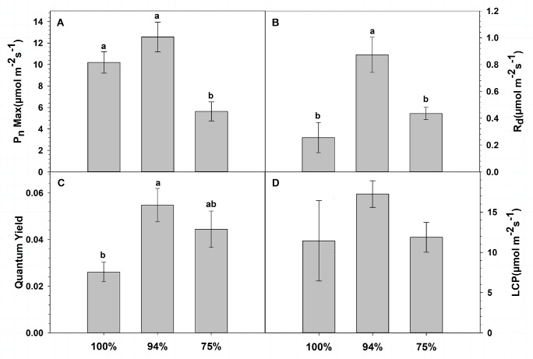

Figure 2: Mean (± 1 SE) with letters denoting significant differences at p < 0.05. A. Maximum photosynthetic rate (P_{n}max) B. Dark Respiration (R_{d}) C. Quantum Yield(QY. D. Light Compensation Point (LCP)

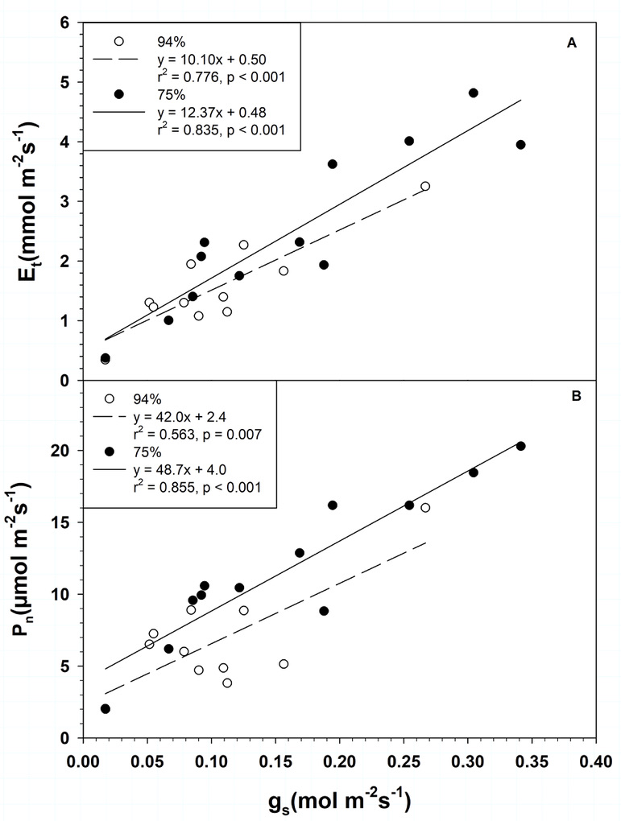

Figure 3. July afternoon transpiration (A: E_{t}) and net photosynthesis (B: P_{n}) as a function of stomatal conductance (g_{s}) for trees in the 94% and 75% stands.

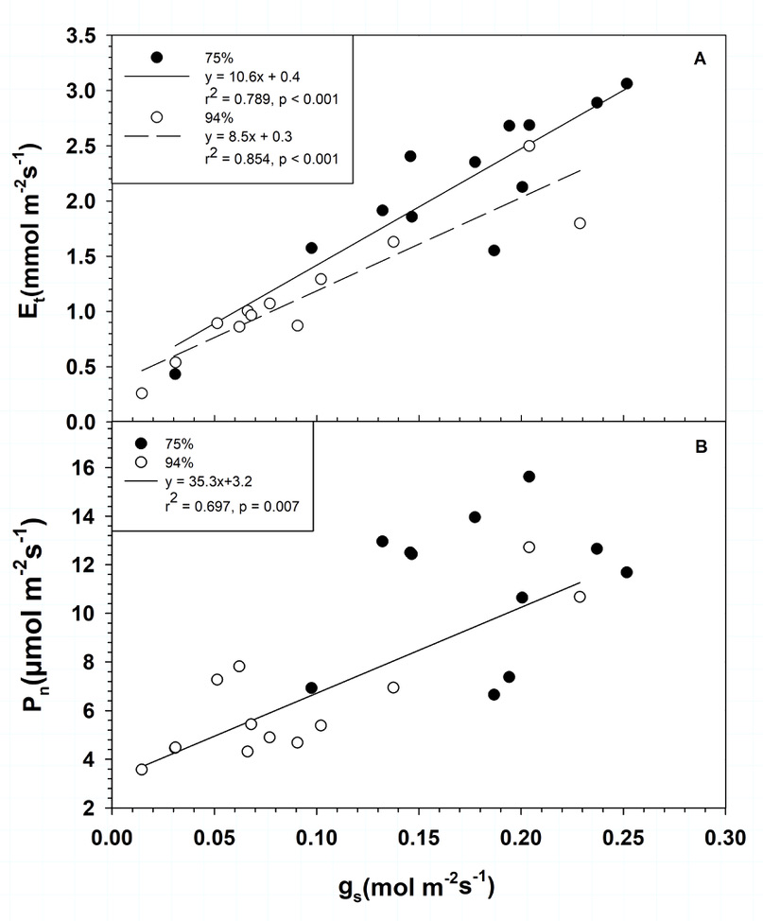
Figure 4. August afternoon transpiration (A: E_{t}) and net photosynthesis (B: P_{n}) as a function of stomatal conductance (g_{s}) for trees in the 94% and 75% stands.

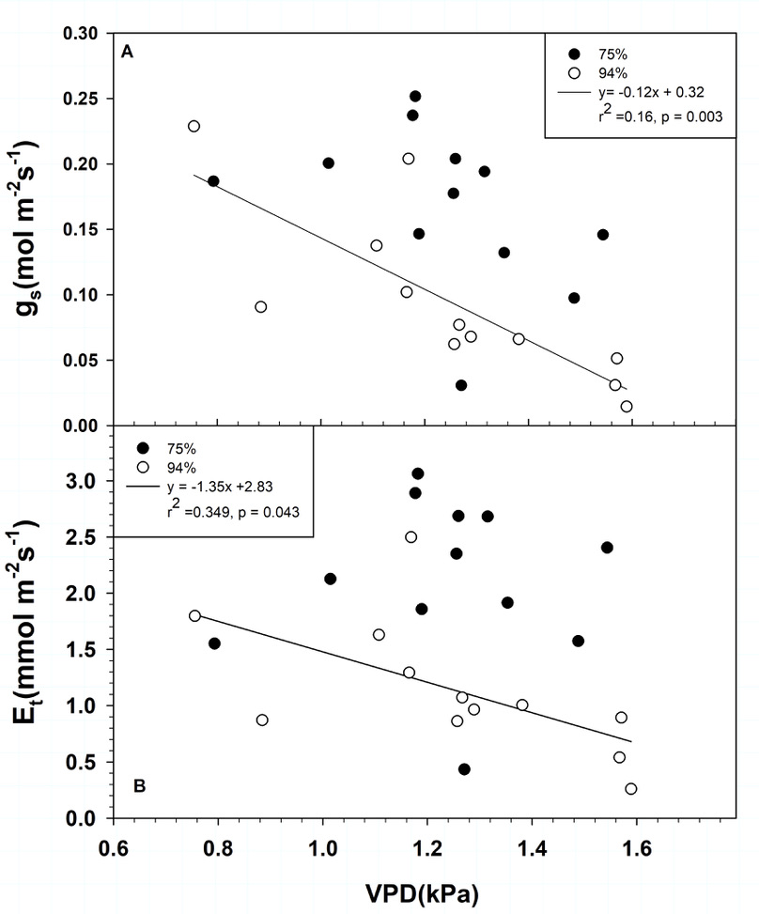
Figure 5. August stomatal conductance (A: g_{s}) and transpiration (B: E_{t}) as a function of vapor pressure deficit (VPD) trees in the 94% and 75% stands.

